Software Security

Lecture 1

* Assured protection on information, aka data
  + Prevent unauthorized access, disclosure, disruption, modification, inspection, recording or destruction of information
* Properties of network security
  + Confidentiality and integrity on network traffic
  + In addition to the above:
    - Define the police4s/rules to prevent and monitor unauthorized access, modification, or denial of a computer network and network-accessible resources
* Definitions of common terms
  + Threat
    - A potentially dangerous event that if occurs, breaches a desirable security property of a system
      * E.g. stealing/transferring money from a user’s online bank account
  + Attacker
    - A malicious entity with a motive to realize a threat on a system (i.e. attack the system)
      * E.g. a bank theft criminal organization
  + Vulnerabilty
    - A weakness in a system is exploitable by an attacker to realize a threat
      * E.g. an online bank server storing user passwords in a publicly accessible server location
* Two common vulnerabilities
  + Implementation Vunerability (bug)
    - Incorrect code implementation of the design functionality
    - Easy to spot in code and detectable by automatic vunerability scanning tools
      * Buffer overflow, input validation
  + Design Vunerability (insecure protocol)
    - Flaw in the logic/ protocol of the software
      * Incorrect use of cryp[tography, unauthorized access to shared resources
    - Detecable at the design stage from design specs
    - Not easy to automate dectection
    - Sometimes a bad tradeoff of usability over security
* Attackers: who are they?
  + Criminals seeking finicial gain
  + Criminal organization
  + Insiders revenge
  + Hackers driven intellectuasl challenge
  + User mistakes
  + Terroisrist/nations
  + Agents seeking information
  + Disrupt military
* Attacklers: Financial incentives
  + Infection of individual machines for:
    - Ip Address theft, exploited for:
      * Click fraud
        + Attack gets an ad syndicate
        + Attack uses machine to issue fake clicks to ads
        + Attack earns fraction of revenue
      * Spam email
    - User private data theft
      * Man in the browser keylogger spyware
        + E.g. steal users passwords
* Significance of SW security
  + Loss of productivity
  + Loss of trust
  + Loss of money

Lecture 2

* Secure Software development approaches
  + Three pillars:
    - Risk Managments framework
    - Touch points
    - Knowledge
* Risk Management Framework
  + A continuous risk management process is an essential part to security
  + It identifies, ranks and tacks and understands software security risks
  + RMF
    - An overall approach
    - Allows consistent and continuous expertise-driven approach to risk management
    - Consistently track and handle risks

Understand business context 🡪 Identify business and technical risks 🡪 synthesize priority and rank risks 🡪 define risk mitigation strategy 🡪 carry out fixes

* Touch points
  + Architectural risk analysis (design)
    - Find design level vulnerabilities
      * Account for 50% of security problems
      * A higher-level understanding is required
    - Need to perform threat modelling
    - Business aspect: rank threats by risk, remedy action
    - Introduce mitigation to defend against threats
  + Risk based tests
    - Testing aspects (units and system) can be done before implementation
  + Abuse cases
    - How to abuse features? How can users misbehave?
  + Security requirements
    - What aspects need to be protected
  + Code review
    - Find implementation level vunerabilites
    - Useful tools (code anaylsers)
    - Knowledge of common implementation vulnerabilities
  + Penetration testing
    - Test implemented system in its usage environment
  + Security operations
    - Use knowledge gained in the field to improve future designs
* Knowledge
  + Sofware sec knowledge catalogs
    - Principles
    - Guidelines
    - Rules
    - Vulnerabilities
    - Exploits
    - Attack patterns
    - Historical Risks
* SDL
  + Threat modelling approaches (next week)
    - STRIDE
      * Spoofing, tampering, repudiation, info disclosure, DoS and EoP
    - Dread
      * Damage potential
      * Reproducibility
      * Exploitability
      * Affected Users
      * Discoverability
* Goals of Trustworth Computing
  + Security
    - The customer can expect that systems are resilient to attack and that the CIA of the system and data are protected
  + Privacy
    - The customer us able to control data about themselves
  + Reliability
    - The customer can depend on the product to fulfil its functions
  + Business integrity
    - The vendor of a product behaves in a responsive and responsible manner
* SD3 strategy of the secure windows
  + Secure by design
    - Security team
    - Secuity training
    - Develop threat models during design
    - Adhere to design and coding guidelines
    - Fix all bugs ASAP
    - Evolve the guidelines
    - Develop regression tests for fixed vunerabilites
    - Simplify code
    - Perform penetration analysis before shipping
  + Secure by default
    - Do not install all features and capabilities by default
    - Allow least privilege in your applications
    - Apply appropriate protections for resources
  + Secure in deployment
    - Means to administer: security functionality
    - Good quality security patches ASAP
    - Instructions for use in a secure manner
* Building Security in maturity model
  + Governance
    - Strategy and metrics
    - Compliance
    - Training
  + Intelligence
    - Attack models
    - Security features and design
    - Standards and requirements
  + SSDL Touch points
    - Architecture analysis
    - Code review
    - Security testing
  + Deployment
    - Penetration testing
    - Software environment
    - Conifuration management and vunerability management
* Threats
  + Input validation
    - Problems caused by meta characters
    - Problem trusting user input
  + API abuse
    - Contract between caller and callee
    - API abuses are caused by the caller failing to honor its end of this contract
      * E.g. one of the most common abuses is to repackage a mobile app
  + Security features
  + Time and state
    - Distrubuted computing is about time and space
    - For modules to communicate, state information must be shared
  + Error handing
    - Try to break software – just throw some junk input at the program and see what happens?
    - Handle errors correctly and safely, if possible
    - Do not give to much info to attackers
  + Code quality
  + Encapsulation
    - Is about drawing strong boundarties between objects and setting barriers between them
    - Trust and trust models are required for boundary crossing
  + Environment
    - Physical environment: the people who are managing and accessing the system resources
      * Can be controlled with a well-defined security policy
* Evaluating trust in computer systems
  + Evaluation if a formal methodology and set of procedures used to measure the degree of trust that can be placed in a system
  + The most popular evaluation schemes are:
    - The orange book
    - The common criteria

Lecture 3

Threat modeling

* Threat modeling basics
  + Who
    - Building a threat model
      * PM owns process
      * Testers
        + Identify threats in the design phase
        + Use threat models to drive test plans
      * Developers create diagrams
    - Customers for threat models
      * Product teams
      * Users via user education
      * External quality assurance resources
  + What
    - Consider, document and discuss security in a structured way
    - Threat model the following:
      * The whole product
      * The security-relevant features
      * The attack surfaces
  + Why
    - Produce software that is secure by design
      * Improve the designs in the same way that we have improved the code
    - Because attackers think differently
      * Creator blindness/new perspective
    - Allow you to predictably and effectively find security problems early in the process
* STRIDE
  + Spoofing - Authentication
  + Tampering - Integrity
  + Repudiation – Non-repudiation
  + information disclosure - Confidentiality
  + DoS - Availability
  + EoP – Authorization
* Process
  + Diagram 🡪 identify threats 🡪 mitigate 🡪 validate
* Process diagramming
  + Use DFD’s
    - Include processes, data stores, data flows
    - Include trust boundaries
    - Diagrams per scenario may be helpful
  + Update diagrams as the product changes
  + Enumerate assumptions and dependencies
* 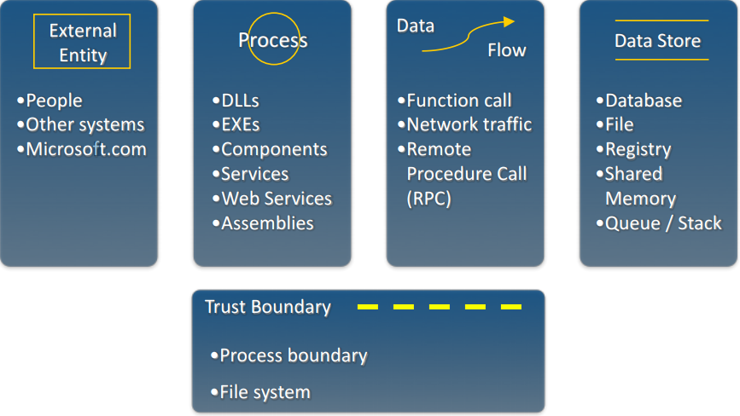Diagram elements
* Diagrams: trust boundaries
  + Add trust boundaries that intersect data flows
  + Trust boundaries represent the border between trusted and untrusted elements
  + Points/surfaces where an attack can interject
    - Machine boundaries, privilege boundaries and integrity boundaries are examples of trust boundaries
    - Threads in a native process are often inside a trust boundary because they share the same privileges, rights, identifiers and access
  + Processes talking across a network always have a trust boundary
    - May create a secure channel, but they are still distinct entities
    - Encrypting network traffic is an instinctive mitigation
      * Bur does not address tampering or spoofing
* Diagram iteration
  + Iterate over processes and data stores and see where tthey need to be broken down
  + How to know it needs to be broken down
    - Detail is needed to explain the secutiy impact of the design
    - Object crosses a trust boundary
    - Words like sometimes and maybe indicate you have a combination of things that can be broken out
      * Sometimes this datastore is used for X, probably add a second datastore to the diagram
* Diagram layers
  + Context Diagram
    - Very High level: entire product

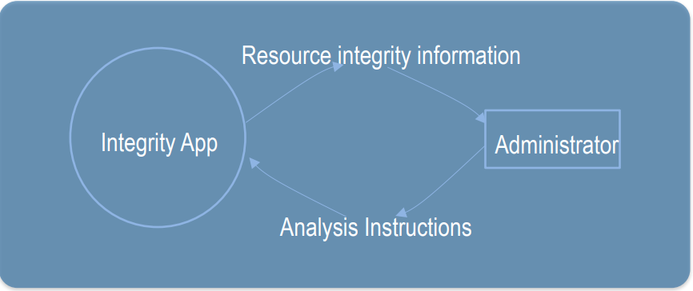

* + Level 1
    - High level: single scenario

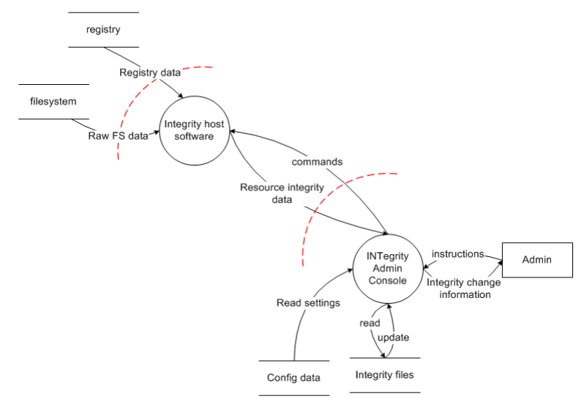

* + Level 2
    - Low level: detailed sub-components
  + Level 3
    - More detailed
    - Rare to need more layers
* Diagram validation
  + Data comes from external entities

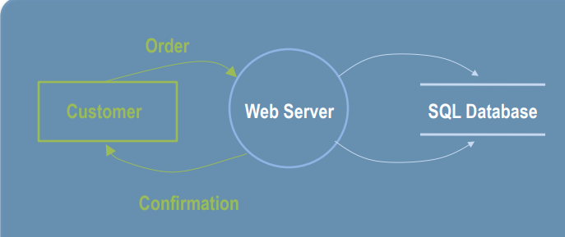

* + You write to a store for a reason

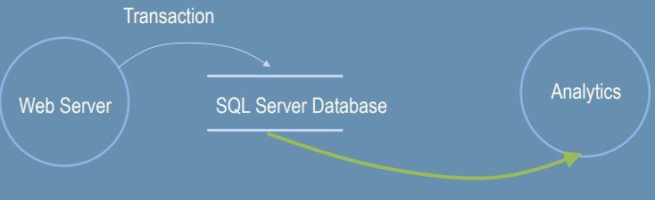

* + It goes through a process

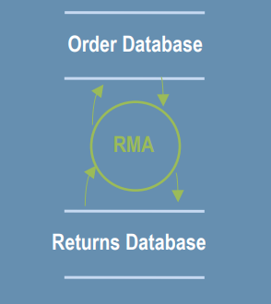

* Diagrams should not resemble
  + Flow charts
  + Class diagrams
* Identify threats
  + Experts can brainstorm
  + How to do this without being an expert
    - Use STRIDE to step through the diagram elements
    - Get specifics about threat manifestation
* Threats
  + Threat: Spoofing
  + Property: Authentication
  + Definition: Impersonating something or someone else
  + Example: pretending to be someone else
  + Threat: Tampering
  + Property: Integrity
  + Definition: Modifying data or code
  + Example: Modifying a DLL on disk, data record in a database
  + Threat: Repudiation
  + Property: Non-Repudiation
  + Definition: Claiming to have not performed an action
  + Example: I didn’t send that email
  + Threat: Information Disclosure
  + Property: Confidentiality
  + Definition: Exposing information to someone not authorized to see it
  + Example: Allowing someone to read the windows source code
  + Threat: DOS
  + Property: Availability
  + Definition: Deny of degrade a service
  + Example: Crashing a website via sending large amount of packets
  + Threat: EoP
  + Property: Authorization
  + Definition: Gain capabilities without proper authorization
  + Example: Allowing a user to run commands of the admin

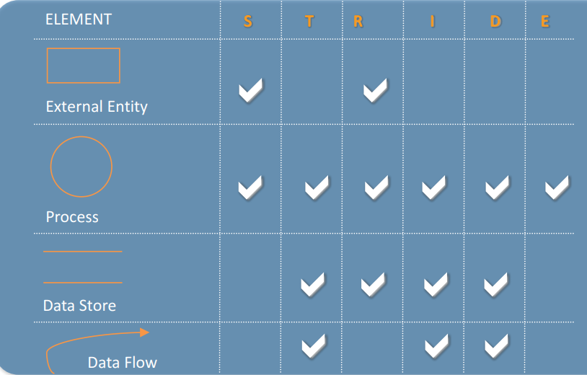

* Apply STRIDE to each element
  + For each item on diagram
    - Apply STIDE
    - Process:
      * S,T,R,I,D,E
    - Data store, data flow:
      * T,I,D
    - External entity:
      * S,R
    - Data flow inside a process:
      * Ignore T,I,D
* Mitigation is the point of threat modeling
  + To address or alleviate a problem
  + Protect customers
  + Design secure software
  + Create great model
  + Identify lots of threats
  + Fix them problems
* Mitigate
  + Redesign to eliminate
  + Apply standard mitigations
    - Cryptography
    - Similar software packages
  + Invent new Mitigation
  + Accept vulnerability in design
* Validate threat models
  + Validate the whole model
    - Does the diagram match the final code?
    - Are all the threats enumerated?
    - Minimum: STRIDE per element that touches a trust boundary
    - Has Test/QA reviewed the model
    - Is each threat mitigated
    - Are mitigation done in a right manner
* Validate quality of threats and mitigations
  + Threats:
    - Describe the attack
    - Describe the context
    - Describe the impact
  + Mitigations
    - Associate with a threat
    - Describe the mitigations
    - File a bug
* Validate info captured
  + Dependencies
    - What other code is being used
    - What security function are in that other code?
  + Assumptions
    - Things you note as you build the model
      * SHA-1 will protect us against SQL
      * GenRandom will give crypto-strong randomness
* Chosen techniques
  + Spoofing identity
    - Authentication
    - Protect secrets
    - Do not store secrets
  + Tampering
    - Authorization
    - Hashes
    - MAC
    - Digital signatures
    - Tamper-resistance protocols
  + Repudiation
    - Digital signatures
    - Timestamps
    - Audit trails
  + Info disclosure
    - Authorization
    - Privacy-enhanced protocols
    - Encryption
    - Protect secrets
    - Do not store secrets
  + DoS
    - Authentication
    - Authorization
    - Filtering
    - Throttling
  + EoP
    - Run with least privilege

Lecture 4

* How malicious user input can affect program execution
  + Buffer Overflow (or overrun / overread vulnerabilities
  + Program allocates a buffer of length N for user input
    - Copies input data without checking input length
    - If length > buffer length N, excess input will overwrite memory addresses after buffer
  + In normal cases, it causes a program crash
  + If carefully controlled, it can be used by hacker to:
    - Overwrite critical program variables
    - Overwrite function return address to point to either desired existing program code or injected by hacker, e.g. a root user shell
* Machine code
  + Intel cpu’s execute x86 machine code
  + any high level language code eventually compiled into binary
  + Machine code consists of basic instructions and manipulated data
  + Assembly language: human-readable form of machine code:
    - replace numerical instruction opcodes by mnemonics
    - machine code and assembly code listing

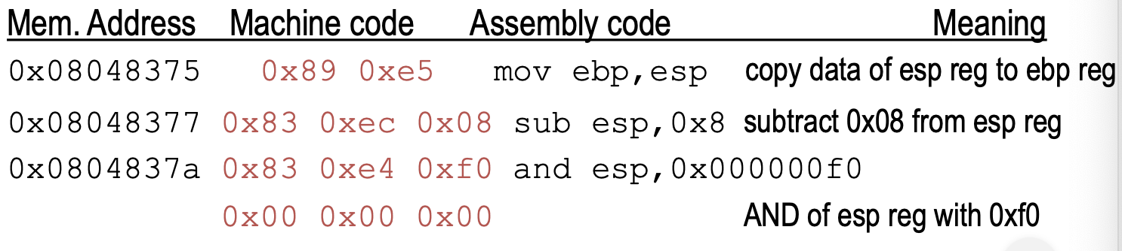

* Buffer overflow vulnerabilities
  + Buffer overflow attacks (exploits) depend on:
    - How programs run “under the hood”
      * Compilation into binary machine code
      * How functions are called
      * Stack frame structure
  + Details depend on programming language, CPU hardware and OS
    - Our examples: C, Intel 86 CPU, linux
* Machine Code
  + General Intel assembly syntax
    - op. mnemonic <destination>, <source>
  + Common assembly instructions
    - Arithmetic: add, sub, inc, mul, div
      * e.g.: add eax, esp //add esp into eax
    - logical: and, or, not, xor, nop
* Process Memory Segments
  + Memory is divided into segments for storing different types of information
  + Text (code)
  + Data segement: global variables
  + BSS: Unitialised global and static
  + Heap: dynamic program data
  + 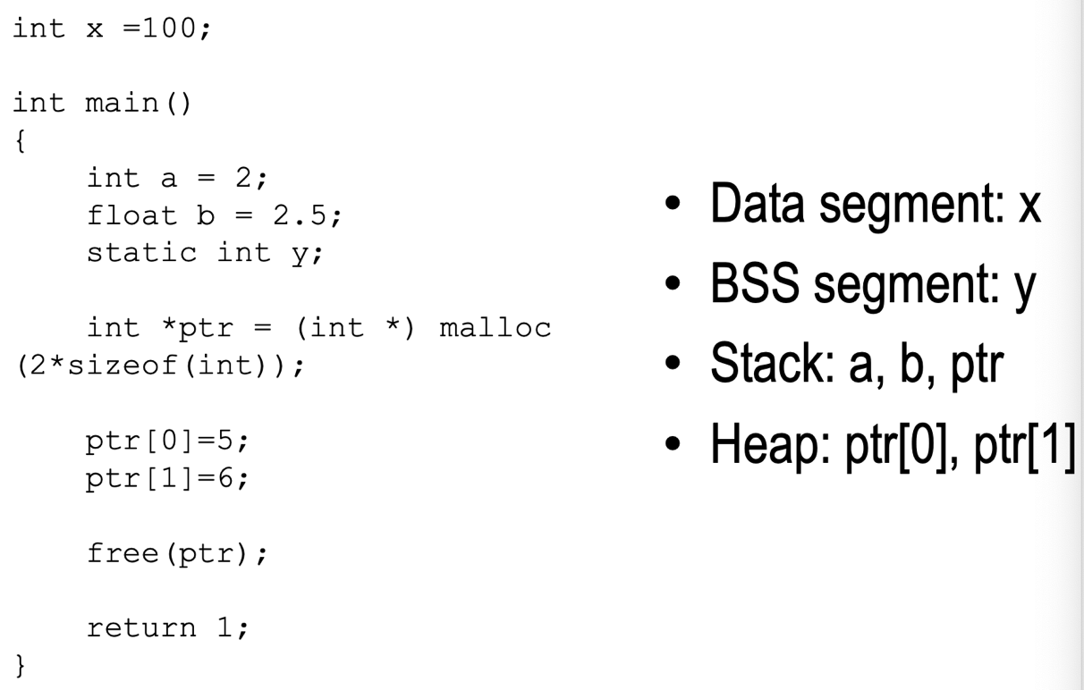Stack: local variables, arguments, context
* Stack: How functions are called
  + Called functions local variables/context/arguments are stored in a stack frame
  + Stack grows from high to low address
  + ESP points to top of stack
  + Push inserts value on top of stack, --esp
  + pop removes value from top of stack, ++esp

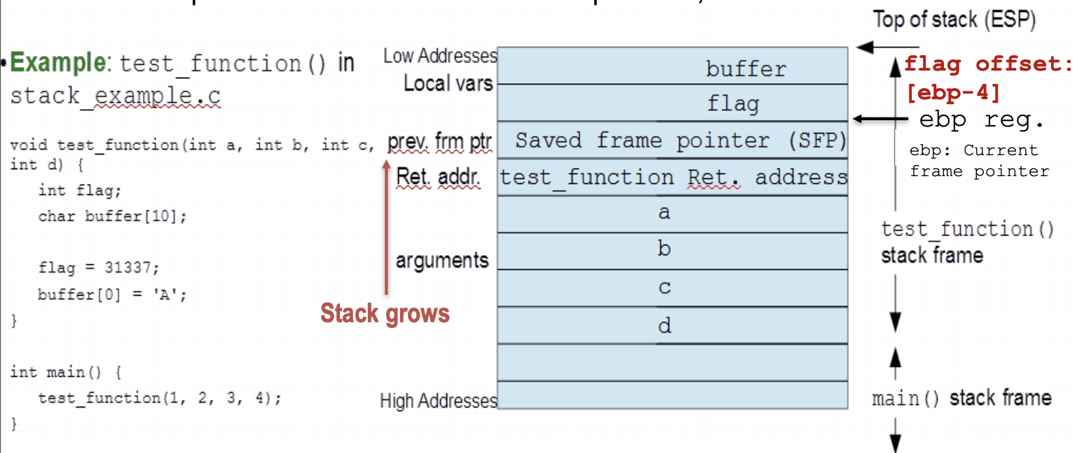

* Buffer Overflow: Ex 1

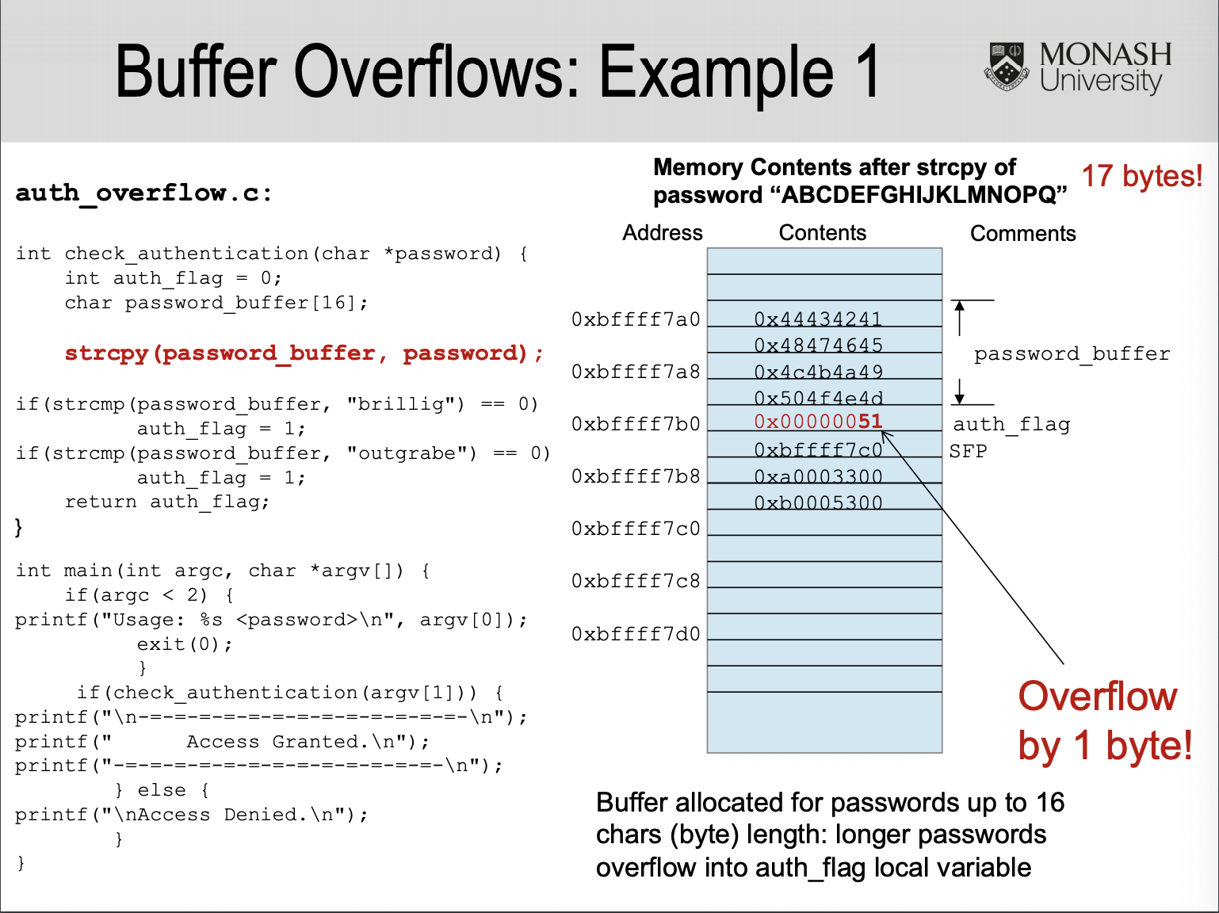

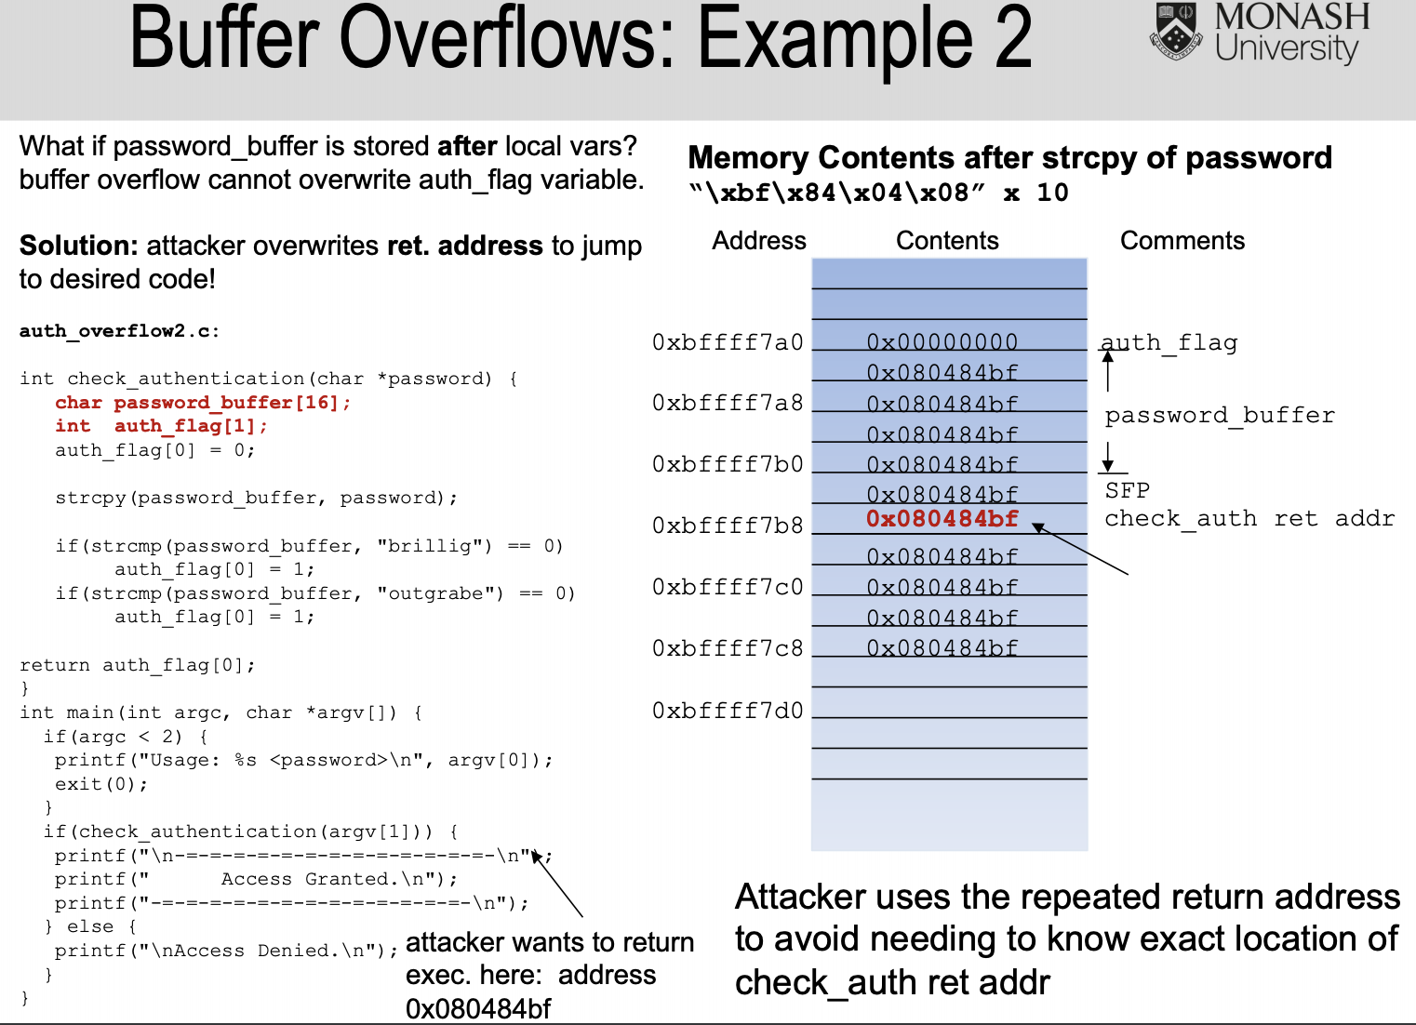

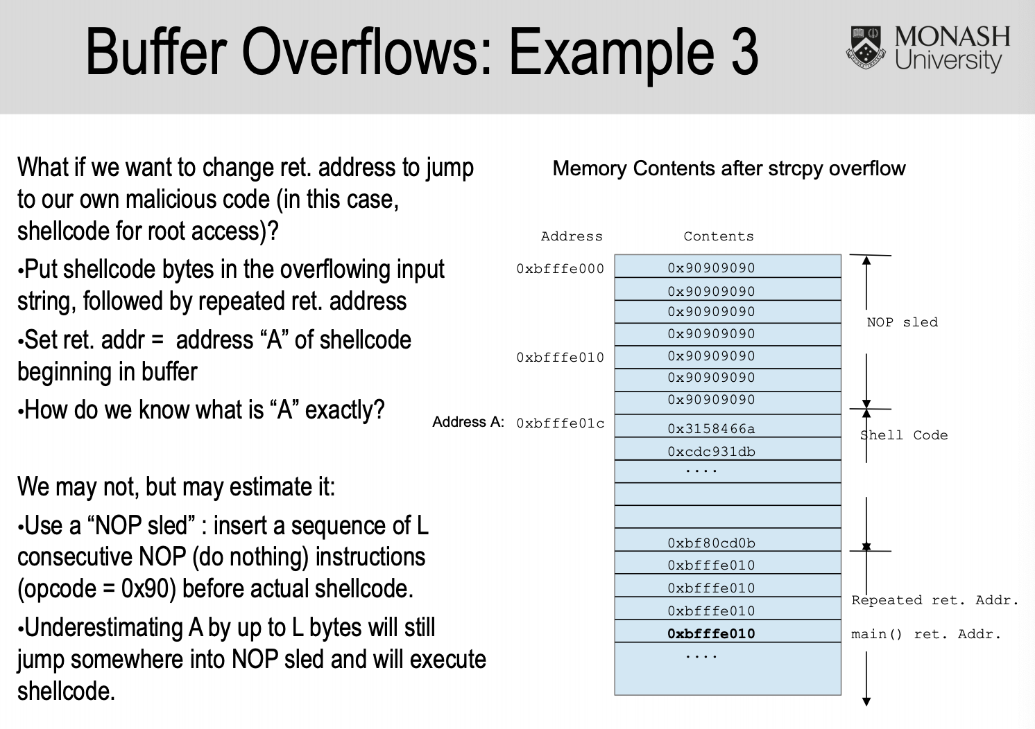

* Buffer Overflows
  + C/C++ issue
    - Java check for array overflow at run-time (slower but safer)
  + Cases that are not obious are
    - Externally provided data is larger than the internal buffer
    - Wrong array indexing
* Buffer Overflow example
  + Use fgets:
    - Accepts a stream argument, but also allows to specify the maximum size of a str and includes in the string any ending newline character
    - A terminating null character is automatically appended after the characters copied to str
* Buffer – safe
  + Using fgets
  + strncat(buffer, input, sizeof(buffer)-1)
* Buffer – Prevent?
  + Bam unsafe functions (read, gets)
  + Use safer:
    - fgets, strncat, etc
      * Takes length as a parameter
  + Always do bounds checking
  + Use through testing and code reviews
  + User source code scanning tools
    - Rats, flawfinder
  + Use compiler enchancement tools
* Mitagtions
  + Address randomization: Randomise the start location of a stack, and other types of memory, such as heap, libraries
    - Limit: a reduced range of the addresses are avalible for random
  + Stackshield: copy return address at some other place to check if modified
  + StackGuard: place a guard between return and buffer to detect modification
  + Hadware: modern CPU supports no execute bit. OS can mark memory region as non-executable
* Format strings
  + Strings of special characters, used to tell C functions to print data in a format
  + 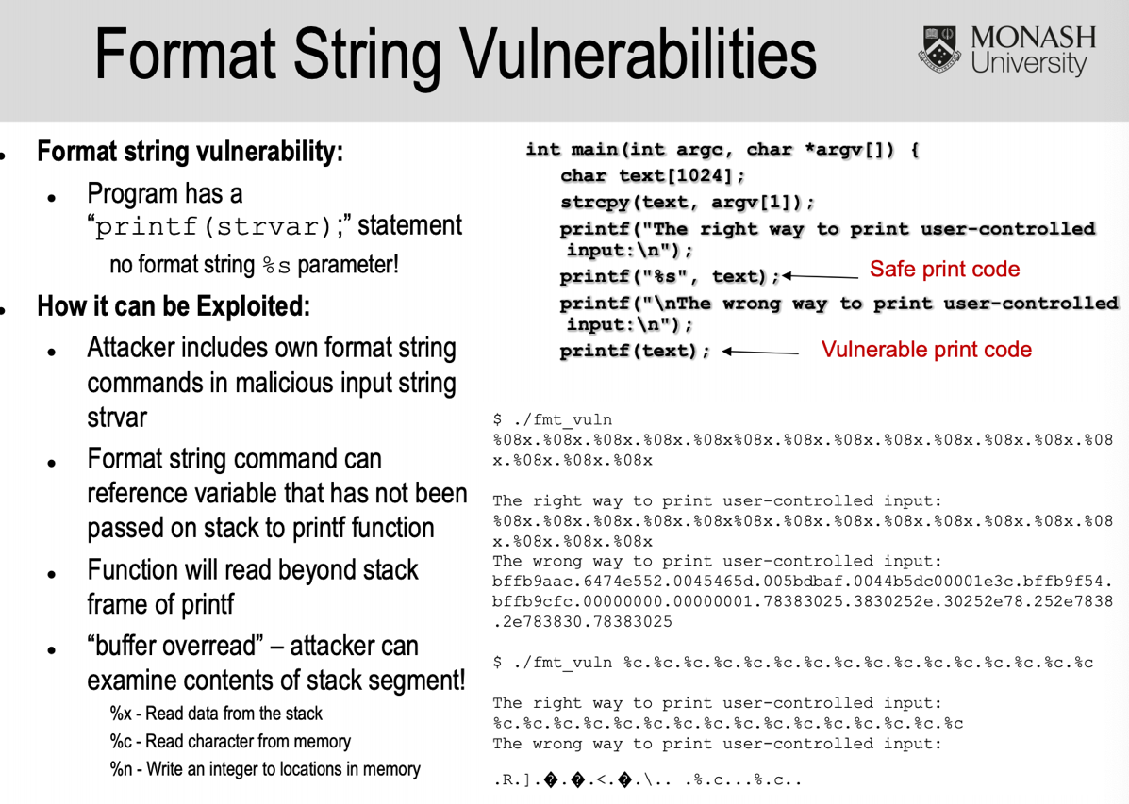Opens door to injection attack
* Trust user input at your own risk
  + Most security vunerabilitys revolve around the attacker providing malformed data to the program
  + Trusting that input is well formed can lead to command injections, buffer overruns, xss, SQL injection
* All input is evil
  + Data must be validated as it crosses the boundary between untrusted and trusted environments
    - Trusted data – data that you or an entity you explicitly trust has complete control over
    - Untrusted data refers to everything else
* Inpit validagtion
  + Principle: look for all data and accept only if all is valid
  + Typically incorporate codes that do white list and or black list
* Regular Expressions
  + Short hand to describe class of strings
  + Uses meta characters to describe RE

Lecture 5

* Integer range errors
  + Integer variables commonly used for array ondexing and arithmetic, e.g. typically on a 32 bit machine
    - Unsigned int: 32 bit
    - int: 32 bit
    - short: 16 bit
    - unsigned short 16 bit
    - Integer variavles can overflow if one writes a value > or < maximum value
    - Maliciously choosen integer overflows can also change program behavior
  + When arithmetic expression involving an integer overflows the max value, the result is reduced modulo

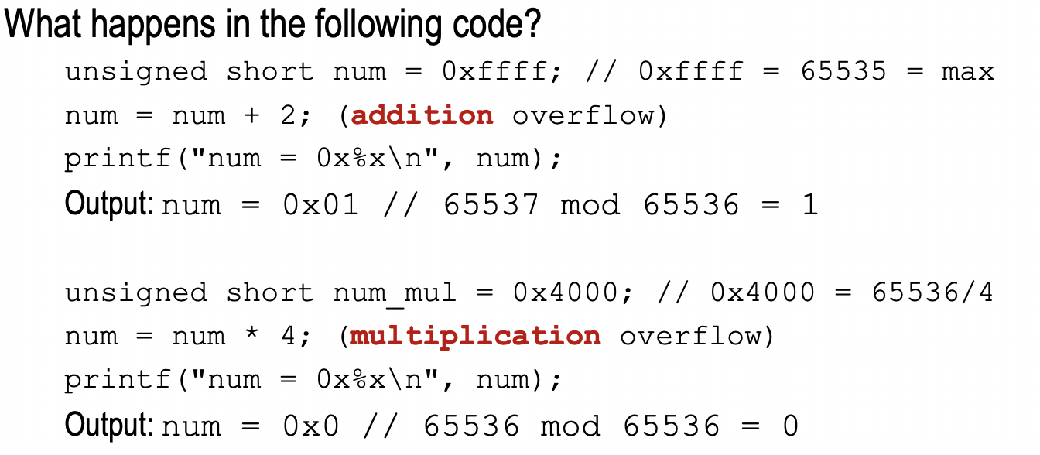

* Negative indexing errors
  + Attack input is pos = -1 passes if test and overflows table
  + Arrays in C start at 0
    - table[-1] overflows table towards lower memory address
* Off by one errors
  + Arrays start at 0, kbuf[799] is last character of kbuf
    - loop overflows kbuf by one int
* Safe code for integer overflow

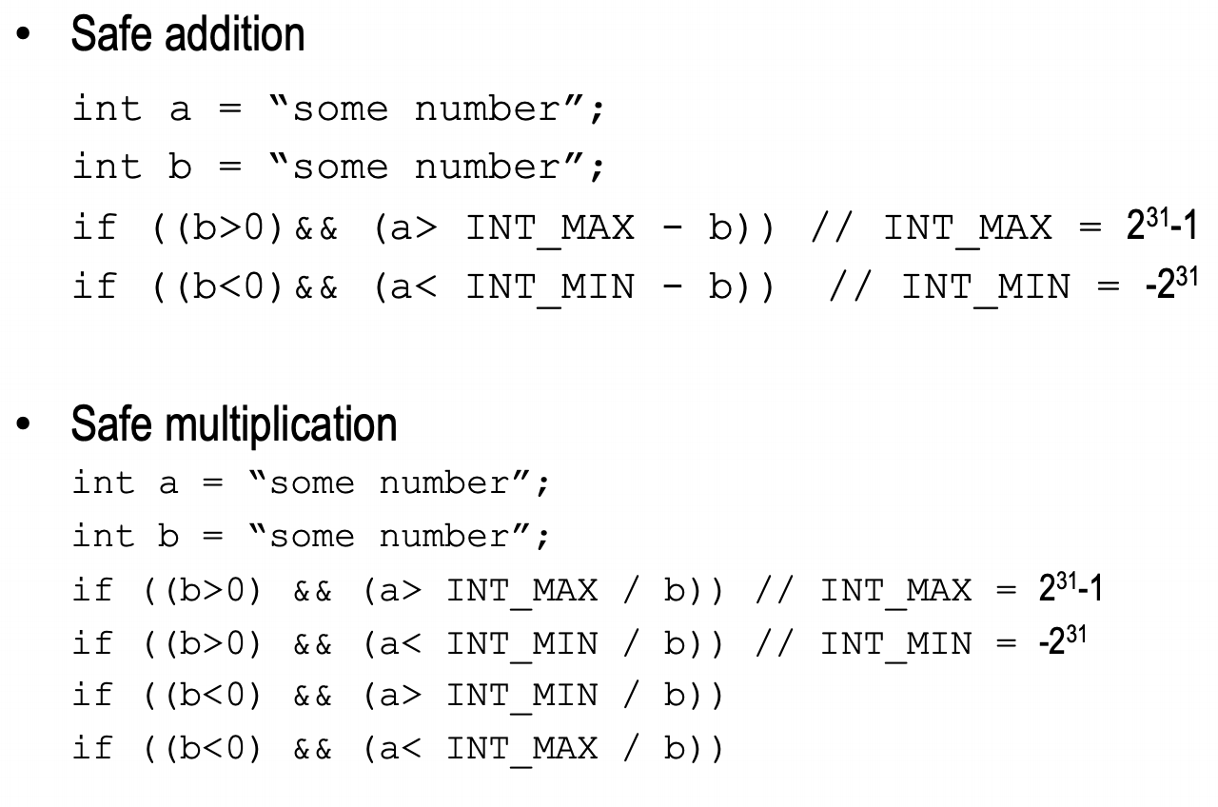

* Pitfalls in Crypto
  + Never invent your own code
    - Can be broken
      * Subtle bugs make insecure
    - Attackers use debuggers, with time and knowledge figure out how it works
    - Use exsiting libraries
* Poor random numbers
  + Crypto uses good random numbers
    - hard to predict keys, salts
      * password hashing
      * random encryption
  + Good random numbers?
    - Evenly distrubted bits
    - Hard to predict next bit
  + Random numbers generated in software using number generators
    - Intialisation: Random seed
    - Generation: Fixed function and output state as random number
* Initialisation vunerabilties
  + - Easy to guess seeds
    - if attacker gets seed, gets all random numbers
* Netcape web browser
  + Seed for random generator SSL encryption kets
    - Time of day
    - Process id and parent process id
  + Using packet timestamps, seconds easily obtain
    - Microseconds – 2^20 possibilities
    - pid+ppid – easily obtained by attacker with account on the machine –ps command
  + Overall 20 bits for attacker to guess seed
    - Just 25 seconds
* Generation vulnerabilities
  + Bad math choices for generator
  + Make it easy to predict the next number
* A good generator
  + Generates evenly distributed number
  + The values are unpredictable
  + Long and complete cycle
* Linear congruential generators meet the first property but fail the second one
  + Xn+1 = (aXn+c) mod m
* Good random numbers
  + Use standard (unpredictable) random number generator
  + make sure random generator seed has enough randomness, >128 bits
* Recap: Symmetric Cryptosystem
  + Scenario
    - Alice wants to send a message to Bob
    - Com channel is insecure and can be eavesdropped
    - IF alice and bob have a symmetric encryption scheme and secret key K, message can be sent encrypted
  + Issues
    - What is a good encryption scheme
    - What is the complexity of enc/decrypt
    - What is the size of the cipher, relative to plaintext

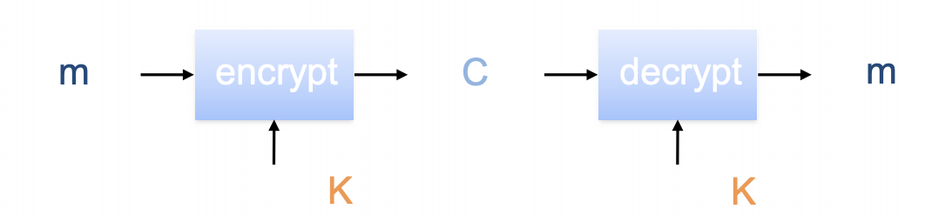

* Basics
  + Notation
    - Secret Key: K
    - Encryption function: Ek(M) or Ek(p)
    - Dcryption function Dk©
    - Plaintext length == ciphertext (roughly)
  + Efficiency
    - Functions Ek and Dk should be efficient
  + Consistency
    - Decrypting the cipgertext yields plaintext

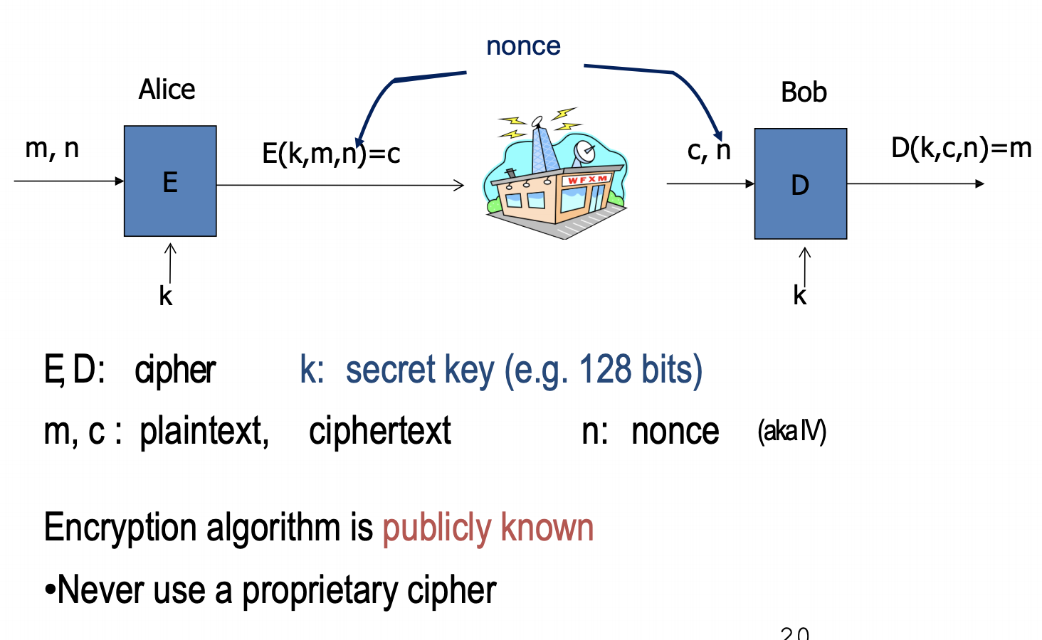

* One time Pads
  + There is one type of cipher that is absolutely unbreakable
  + We use a block shift of keys to enc plaintext of len n with each shift being chosen uniformly at random
  + Since each shift is random, ciphertext is equally likely for any plaintext
* Example:

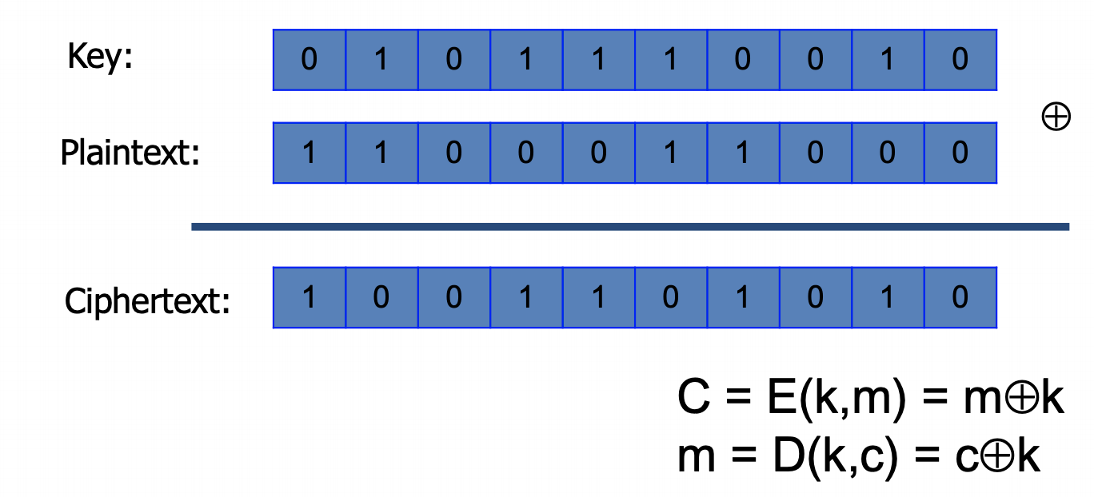

* Weakness of one time pad
  + Key length need to equal plaintext
  + Keys cant be resused
  + Generating and distributing keys is a problem
* Stream Cipher
  + Problem: OTP key is as long as the message
  + Solution: Stream cipher

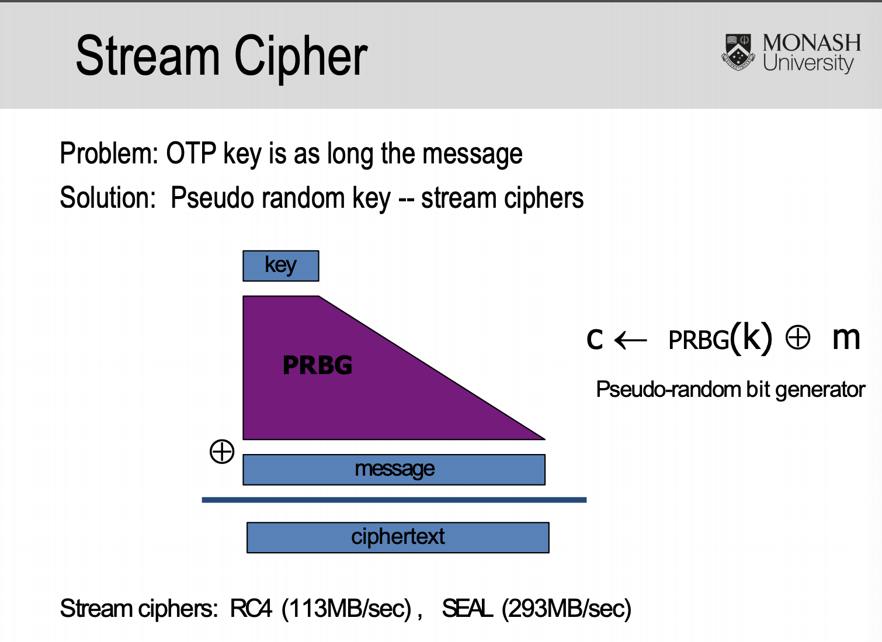

* + Key stream
    - Key input to a random bit generator
      * Produces stream of random like numbers
    - Random sequence of bits S = S[0], S[1] etc
      * unpredictable without knowing input key
    - Can be generated online one bit or byte at a time
  + Stream cipher
    - XOR the message with key stream
    - Suitable for media stream
  + Faster and use far less code
* 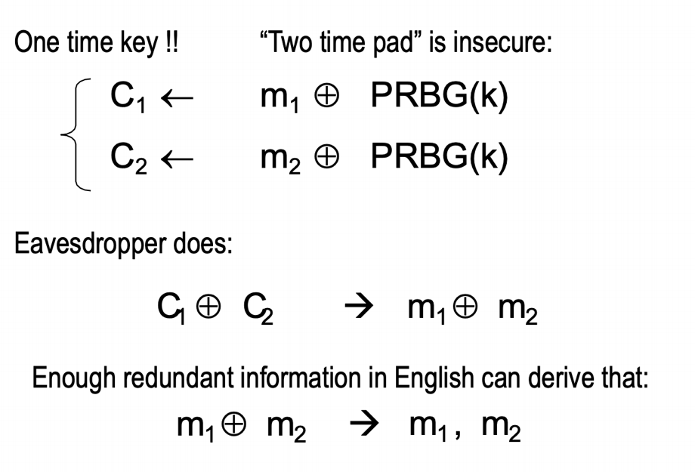Dangers of stream cipher
* Block Cipher
  + In a block cipher:
    - Plaintext and ciphertext have fixed length
    - Plaintext of length n is portioned into a sequence of m blocks
  + Each message is dividied into a sequence of blocks and encrypted or decrypted in terms of its blocks

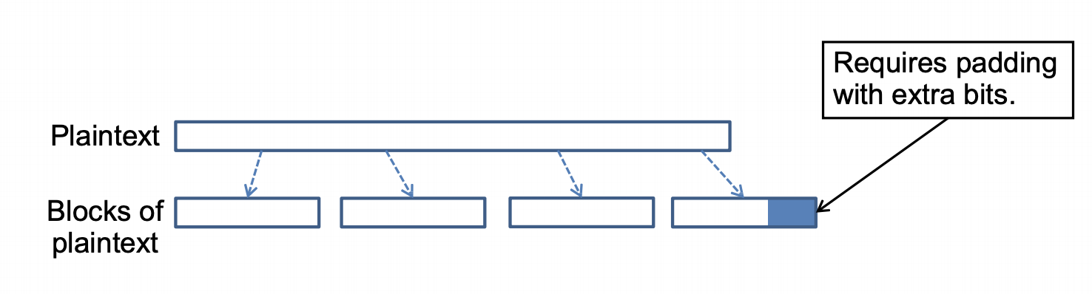

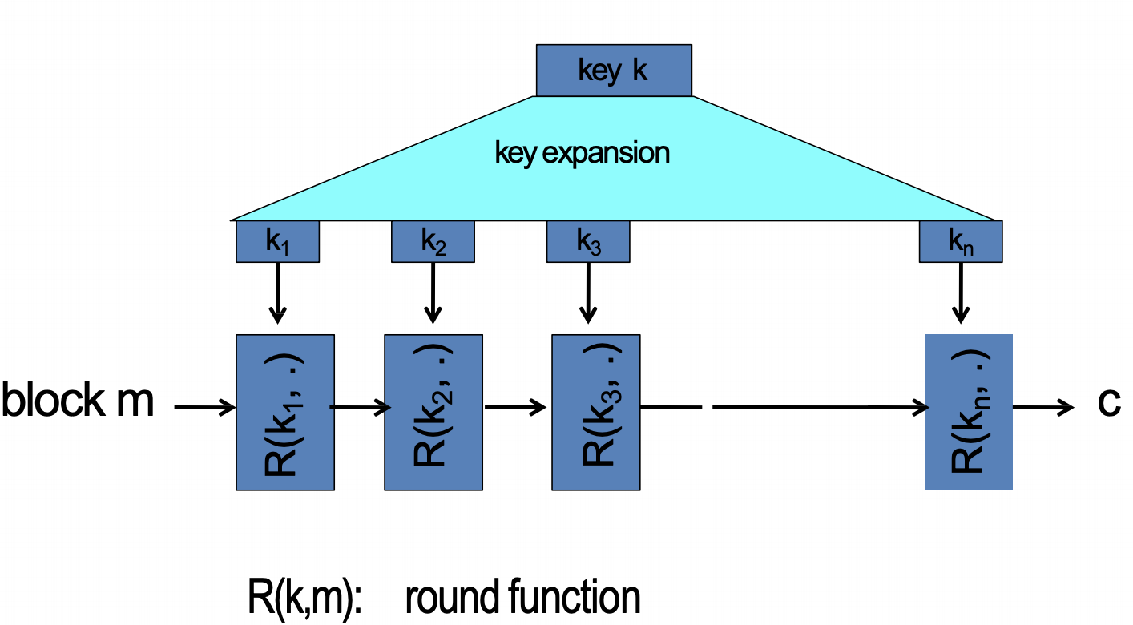

* AES
  + Introduce to replace DES
  + AES operates on 128 bit blocks and can use keys that are 128, 192, 256 bits, yielding ciphers known as AES128, 192, 256
* AES rounds
  + Each round is built on 4 steps:
    - SubBytes – S-box substitution
    - ShiftRows – permutation step
    - MixColumns – matrix multiplication
    - AddRoundKey – XOR step with a round key
  + AES 128: 10 rounds
  + AES 256: 14 rounds
* Mode of Operations
  + A block cipher mode describes the way a block cipher encrypts and decrypts a sequence of message blocks
  + ECB is the cimplest
    - Block P[i], C[i] = Ek(M[i])
    - Block C[i], M[i] = Dk(C[i])

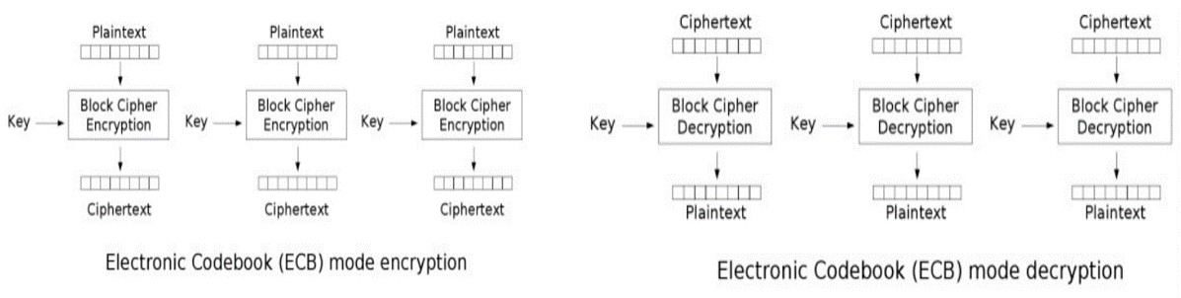

* Incorrect use of block ciphers
  + If m1 = m2 then c1 = c2
  + e.g.

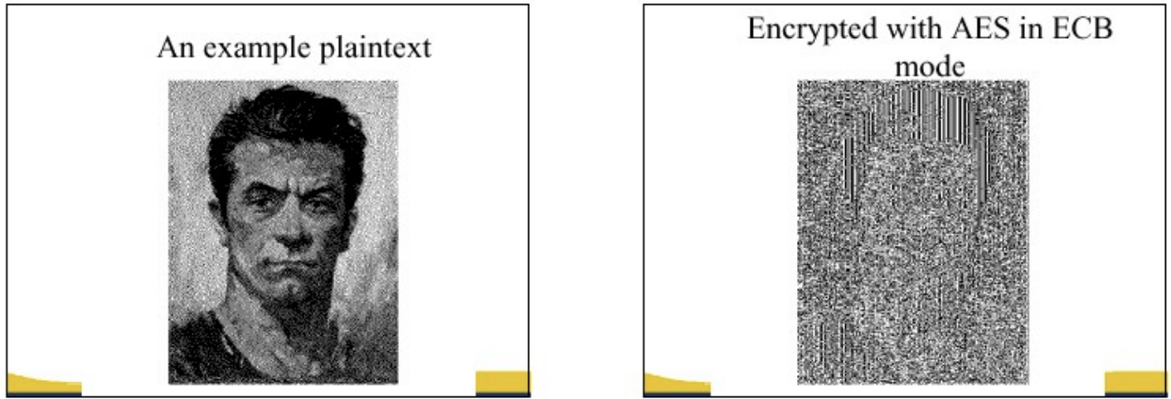

* Strengths and weaknesses of ECB
  + Strengths
    - Is simple
    - Allows for parallel encryption
    - Can tolerate the loss or damage of a block
  + Weakness
    - Documents and images are not suitable for ECB encryption, since patters emerge in plaintext are the same in ciphertext
* Cipher Block Chaining
  + CBC
    - Previous ciphertext block is combined with current
      * C[i] = Ek(C[i-1] XOR M[i])
    - C[-1] = iv
    - Decryption: M[i] = C[i-1] XOR Dk(C[i])

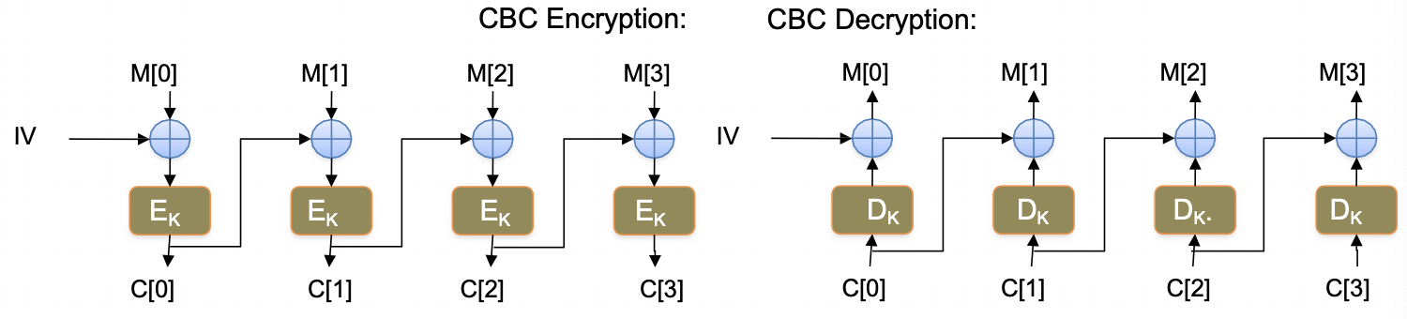

* Strengths
  + Doesn’t show patterns
  + Is mot common
  + Fast and simple
* Weaknessess
  + 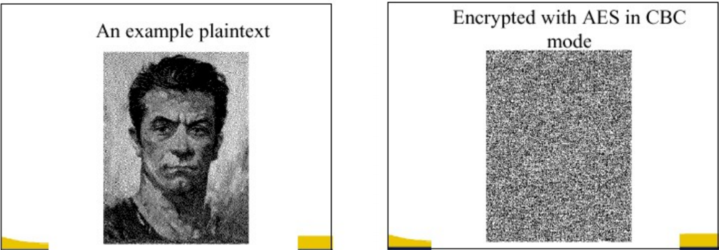CBC requires enc of blocks to be done sequentially
* Key Reinstallation Attacks (KRACK)
  + KRACK is a reply attack that on WiFi protected access protocol (WPA2)
    - Discovered in 2016
  + High-level idea
    - Manipulate and replay cryptographic handshake messages
    - 4-way handshake to negiatie a fresh enc key between AP and client
    - AP will retransmit message 3 if message is lost or dropped
    - Each time client receives this message, it will reinstall the same enc key and nonce (triggering Key/nonce re-use vulnerability

Lecture 6

* Security test != traditional testing
  + Software can be correct but not secure
  + Security bugs can be different from trad bugs
  + Requires different mind set
* Security testing

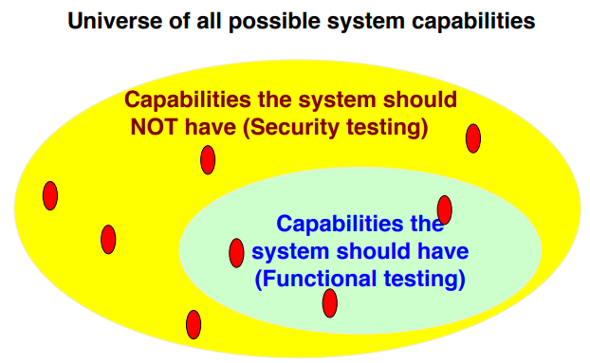

* + Aim is to shrink the yellow area
  + Discover the circumstances under which each of those functions can be performed
* Testing is done at three levels
  + Risk-based Security testing
  + Source code review “white box” testing
    - Manual
    - With a tool: Static code analysis
  + Penetration testing: “Black box” Testing
    - Simulate adversarial behaviors to evaluate security
* Risk based Security Testing
  + Identify threats using threat modeling
    - Microsoft STRIDE
  + Quantify the risk associated for each threat
  + Prioritize the risks for mitigation
  + Decompose applications + identify component interfaces + identify vulnerability
  + Risk based testing is a well-known approach to functional software testing
  + Create DFD and identify the security breach boundaries
  + Identify type of threats and check whether code for any of the possible mitigation method is incorporated
    - E.g. using existing API
  + Test the correctness of the mitigation code
    - Runtime inspection by footprinting 🡪 is the process of discovering what system calls and system objects an application uses
  + For windows
    - Look at sysinternals for windows footprints
    - E.g. Process Explorer can view a number of handles including files, processes, threads, semaphores, events, ports, timer, etc
    - Tools such as “Process Monitor” can intercept file and registry APIs and records of the parameters of a program sends to the OS
  + Unix:
    - Ps – aux is one of the command that will provide useful info for footprinting all the current processes in the system
    - Isof – list of open files
    - Ktrace – to trace a system calls and the return codes and kdumo to dump the trace
* Source code review
  + Code walkthrough “White box testing”
  + Look for bad practices of programming
  + Hard coded passwords, leaking info
  + Data flow issues e.g. data validation
  + Control flow issues: DoS possibility, matching lock/unlock operations
  + Most of the time the source code review concentrates on the language-based security
  + Requires strong experience with both software dev and security
  + Deliverables
    - Report targeted at the developers who will fix the identified vulnerabilities
      * Executive summary
      * List of technical issues identified
      * Glossary, appendices, indexes
* Code review with a tool
  + Manually finding common bugs in huge chunks of code is time consuming/ error prone
  + Can build in tool more common vulnerabilities than a human can keep in the mind
  + Humans better at code understanding / insight than manual search for patterns
  + Static code analyzers (FlawFinder, Fortify)
    - Take code as input (static = no code execution)
    - Search the code for common coding vulnerabilities
    - Produce results in output report file
* Static Code Analyzers
  + Goals:
    - Find common bugs quickly
    - Allow humans to focus on parts of code likely to be risky
  + Limitations
    - Cannot find design level vulnerabilities
    - Cannot make a judgement of importance of a found vulnerability
    - Only detect vulnerabilities in tools rule database
    - Suffer from errors
      * False positive: bugs aren’t really bugs
      * False negative: missed a bug, calling outside APIs, runtime environment unknown
  + Simple (usually free) search based tools
    - E.g. FlawFinder, RATS
    - Search source file for “dangerous functions” known to cause common vulnerabilities
    - E.g. strcpy, gets
    - Produces list of hits and ranks them by risk
    - Better than just pure search
      * Ignores commented code
      * Ignores strings
      * Some risk ranking
* Advanced Static Code Analyzers
  + Examples: Fortify
    - Attempt to improve risk analysis and reduce false positive rate
      * Data Flow analysis: Identifies user-controlled input that is involved in a dangerous operation (long user input data copied into fixed size buffer)
      * Control flow analysis: Identified dangerous operation sequences (e.g. a file is configured properly before use)
* Limits of white box Testing
  + Tester must have knowledge of the program language
  + Sometimes it might not cover realistic cases/conditions in the program
  + Focus on current implementation; missing security features cannot be discovered
* Approaches for Pen Testing
  + Source code reviews
  + Pen testing
    - Evaluate security of your app weakness by simulating malicious attacks
  + Grey box – combo
* Pen testing
  + Exploratory – Manual
    - Black box security testing without the aid of a tool and guided by the testers instinct
  + Systematic – Manual
    - Black box testing without the aid of tool based upon pre-determined security test plan
  + Fuzzing – Automated
    - Aid of tool to help reduce the repetitive nature of testing tasks
* Fuzz Testing
  + Sending deliberate malformed data to a program to generate failures
  + Use combo of known to be dangerous values and random data

– for integers: zero, possibly negative or very big numbers (e.g. - 1,0,0x100,0x1000,0x7ffffffe,0x7fffffff)

– for chars: escaped, interpretable characters / instructions (e.g. %s%p%x%d,.1024d, %.2049d, %p%p%p%p, %x%x%x%x, %99999999999s)

* + Select inputs independently at random from the programs input domain
    - Identify the input domain of the program
    - Map random numbers to the domain
    - Select inputs from the input domain according to probability distribution
    - Determine if the program achieves the appropriate outputs on those inputs
  + Random testing can provide probabilistic guarantees about the likely faultiness of the program
* Fuzz benefits
  + Cheap
  + Increases code coverage
  + Can calculate reliability of an app using probability theory
    - Can augment release criteria. E.g. no random failures for 3 weeks prior to a release
  + Good when
    - Lack of domain knowledge makes it difficult or meaningless to partition the input space into equivalence classes
    - When large volume of data are necessary, such as for stress testing
* Fuzz at Google
  + Several teams, several frameworks
  + 5000+ CPU doing fuzz 24/7
  + 10x more bugs found compared to unit tests
  + 5000+ bugs in?? Chromium
* White vs Black box
  + White box
    - Deep and through testing
    - Maximize testing time
    - Extends testing area
    - Limit: Nonrealistic attack
  + Black box
    - It simulates realistic scenarios
    - Limits:
      * Testing time cannot be maximized in certain scenarios
      * Some areas of the infrastructure might remain untested
* Typical security testing plan
  + Testing goals:
    - Describe the approach used by the testers during testing
    - Organize and implement the testing process
    - Define the test deliverables
  + Project (software) description
    - Describe functionality, architecture, components
    - DFD, trusted boundaries
* Terminology
  + Test plan
    - Document that describes the what, why, who, when and how
  + Test item
    - Software program being tested
  + Test
    - Evaluation of a test item with a clearly defined objective
  + Test case
    - Detailed description of a test
  + Test script
    - Automated sequence of tasks
  + Test procedure
    - Manual sequence of tasks
  + Test run
    - Actual execution of test scripts and procedures
  + Defect
    - Nonconformance of the product to the functional/non-functional requirements of the specification
  + Audit
    - A review of a system in order to validate it. Generally, this either refers to code auditing or reviewing audit logs
* Testing objectives
  + Define security goals through understanding security requirements of the applications
  + Identify the security threats
  + Validate that the security controls operate as expected
  + Eliminate the impact of security issues on the safety and integrity of the product
  + Guarantee that the product will function correctly under malicious attacks
* Categories of Software Attacks
  + Software-dependency attacks
    - Environment within which apps work
  + UI attacks
    - Buffer overflows
  + Attacks against apps design
    - Trapdoors
  + Attacks against design implementation
* Test plan for software dependency attacks
  + Third party modules
    - Blocks access to libraries
    - Manipulate the apps registry values
    - Force the app to use corrupt files
    - Manipulate and replace files that the app creates, reads, writes
    - Force the app to operate in low memory disk space and network availability.
* Test plan for UI attacks
  + Malformed user input
    - Overflow input buffers
    - Examine all common switches and options
    - Explore escape characters
    - Testing for error handling
* Test plan design attacks
  + Vulnerabilities at design level
    - Try common defaults and test account names and passwords
    - Expose unprotected test APIs
    - Connect to all ports
    - Face the source of data
    - Create loop conditions in any app the intercepts scrip, code or other user logic
    - Use alternate routes to accomplish task
    - Force the system to reset values
* Test plan for implementation attacks
  + Time of check and time of use
    - Check the state of a resource before using, but the state can change between the check and the use
  + Create files with the same name as files protected with higher classification
  + Look for temporary files and screen their contents for sensitive info
  + Side channel analysis
  + Reverse engineer
* Security testing for cloud based apps
  + Create a plan
    - Applications: Identify UI and APIs
    - Data access: Identify how the data will be pen tested through the application or directly to the database
    - Network access: Identify how well the network protects the app and data
    - Virtualization: Identify how well the virtual machines isolate your workload
    - Compiance: Identify laws and regulations you need to comply with
    - Automation: Identify the automated pen testing tools

Lecture 8

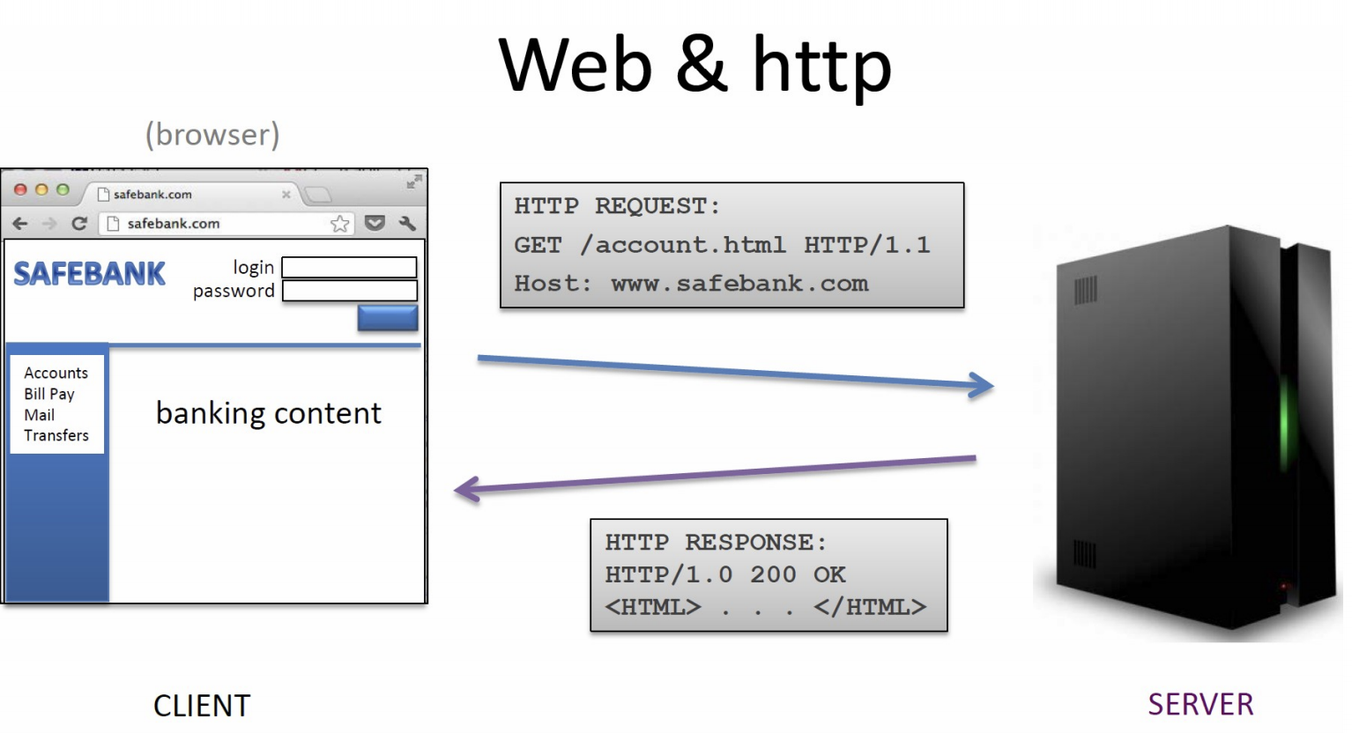

* URLs
  + Global identifiers of a netwroks
* E.g.

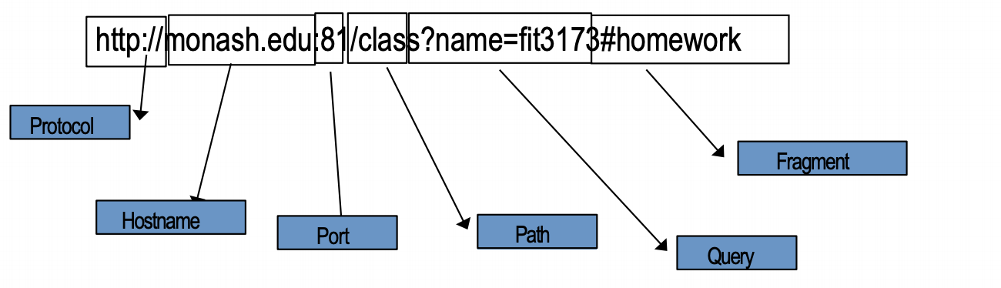

* Special characters are in hex
  + %0a = newline
  + %20 or += space, %2B =+
* 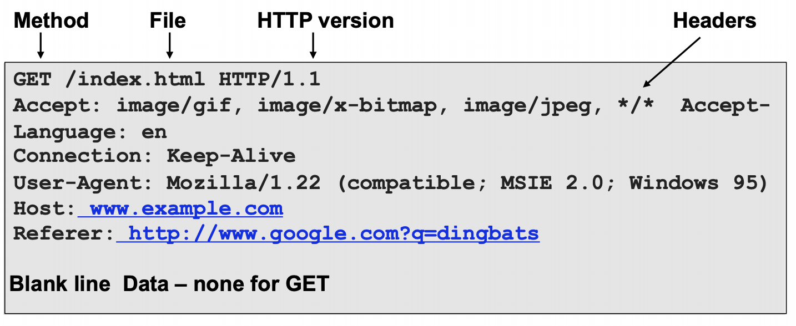HTTP Request

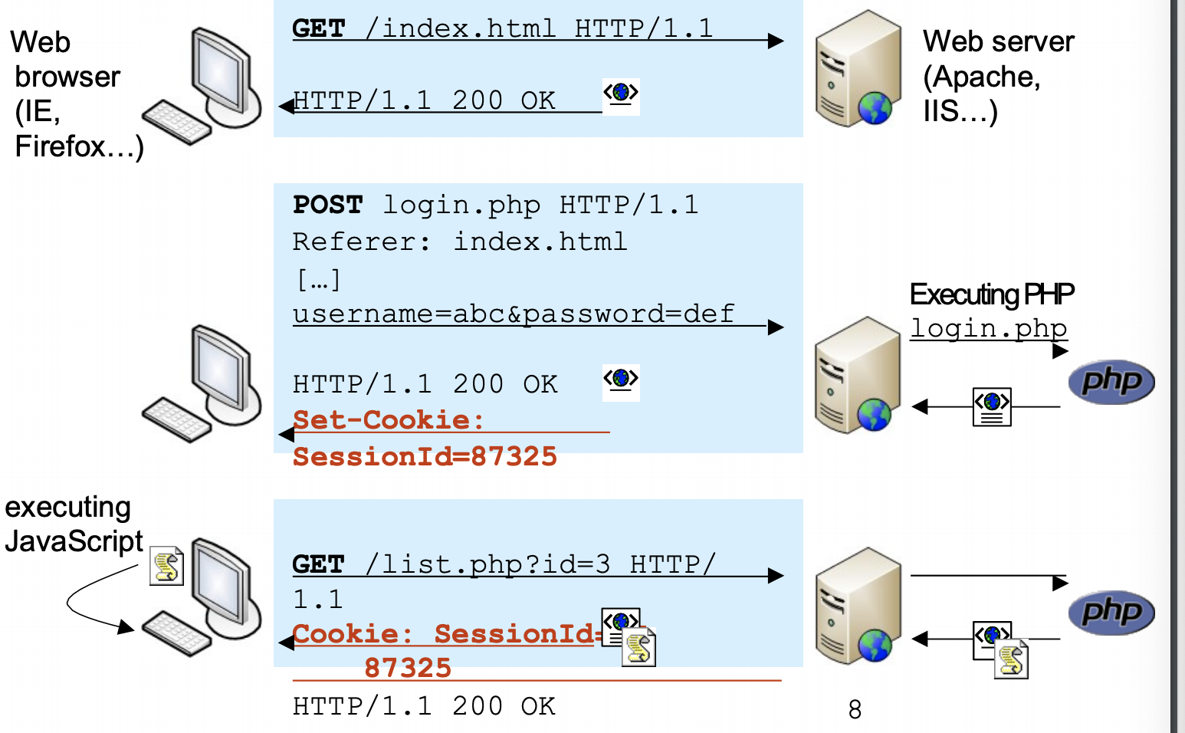

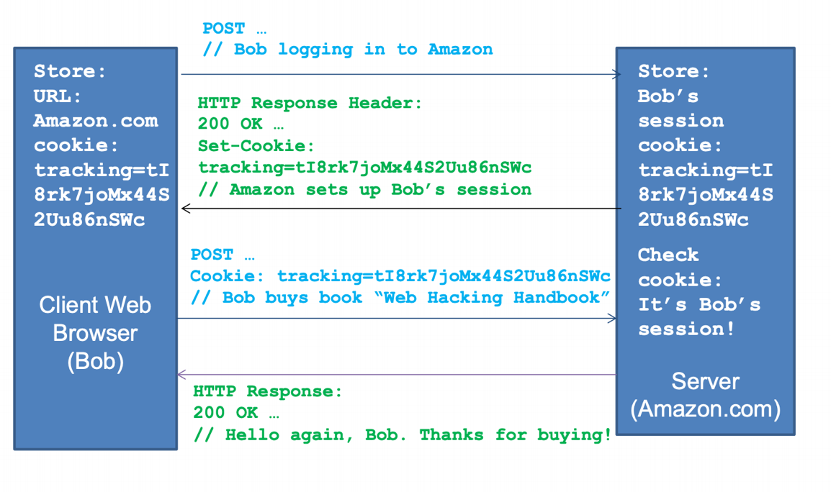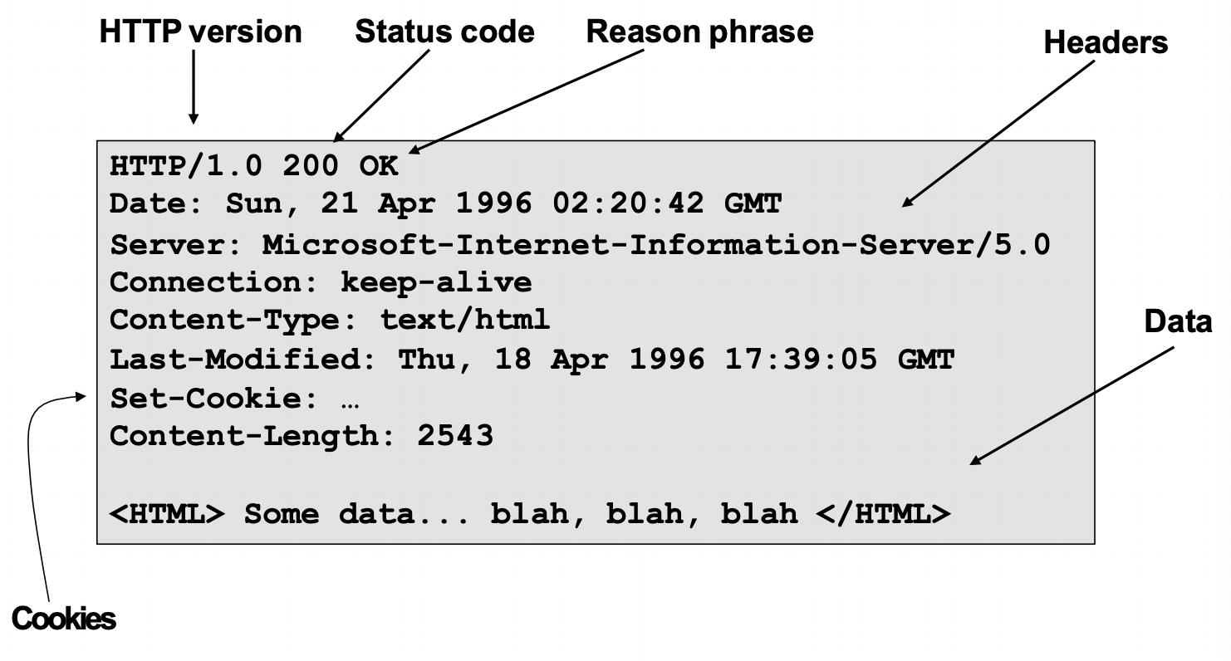

\

* Browser side: HTML
  + Main web page interface langues
  + Tag based for formatting documents
  + Hyperlinks that users click
    - Browser displays as a link
    - When user clicks, issues request
      * GET: (url)/ HTTP/1.1

Host: (url)

* + Forums
    - Mechanism for user input
    - When user clicks a button, e.g. login button

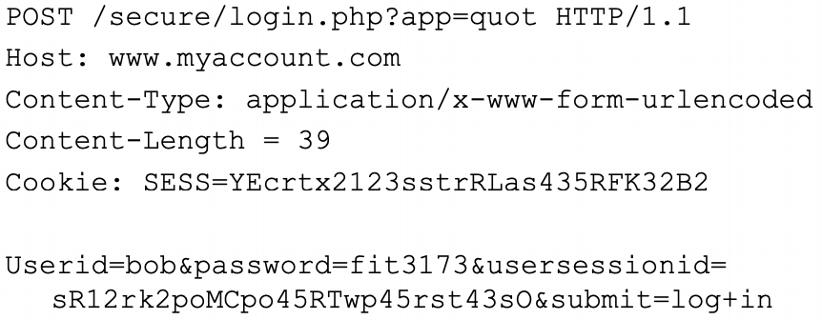

* Javascript
  + Allows processing client side
  + Uses:
    - Validating user input locally, fast and dynamically modifying UI in response to user input
    - Reading / Updating HTML elements
      * DOM – Allows scripts to access individual HTML elements
  + E.g.

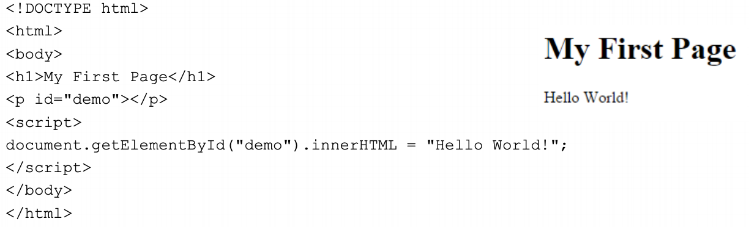

* Web Programming Language
  + Server side programming languages
    - PHP, ASP.NET, Java
  + General purpose languages for implementing web app logic
    - Generate dynamic page content
    - Create, open, read etc files on server
    - Collect form data
    - Send and receive cookies
    - Add, delete and modify data
    - Restrict users to access some pages on your website
    - Encrypt data
* Service Side: Database Query Languages
  + SQL
    - Variants: Oracle, MS-SQL, MySQL
  + SQL manages relational database
    - Consists of tables
    - Each table has a number of rows
    - Each row has a n umber of columns
  + SQL language queries: read, update, add or delete data
    - E.g. SELECT email FROM users WHERE name = ‘alice’
* Goals of web security
  + Safely browse web
    - Users should be able to visit a variety of web sites, without incurring harm:
      * No stolen info
      * Site A cannot compromise session at site b
    - Secure web apps
      * Apps delivered over the web should have the same security properties we require for stand-alone apps
* Web attacker
  + Control attacker.com
  + Can obtain SSL/TLS certificate for attacker.com
  + User visits attacker,com
    - Or: runs attackers facebook app
  + Network attacker
    - Passive: Eavesdropper
    - Acrive: Evil router, DNS poisoning
  + OS/Malware Atacker
    - Attacker escapes browser isolation mechanisms and run separetly under controls of OS
* Web sec ‘History’
  + Example of bolt-on security
  + Originally, web was made to allow physicists to share their research papers
    - Only textual web pages + links to other pages
    - No security
  + Then we added images
    - Crucial decision: a page can embed images loaded from another web server
  + Then audio/video, js, CSS etc
* Goals Revisted
  + Secure web apps
    - https – http over SSL
      * Provides encryption for the browser server traffic
      * Prevents eavesdropping, man in the middle
      * Helps users unsire authencity of the server
      * Does not prevent XSS or SQL injection
* Focus on web apps
  + Web apps are
    - Useful the desktop software
    - Publicly available
    - Easy target for attackers
  + Easy to develop, not so easy to develop well and securely
  + Often vulnerable, this making the server, database, internal network and data insecure
* Threats
  + Info disclosure
  + Tampering
  + Spoofing/ EoS
  + DoS
  + Foot in the door
  + Web defacement
* A2: Broken authn & session management
  + Understand session hijacking techniques
    - Session fixation (attacker sets victims session id)
    - Stealing session id: eavesdropping, XSS
  + Session management
    - Generate new session ID on login
    - Use cookies for storing id
    - Set session timeout and provide logout possibility
    - consider enabling same IP policy
    - require https
* A7: Missing Function Level Access Control
  + Hidden URLs that don’t require further authorization
    - To actions
      * http://site.com/admin/adduser?name=x&pwd=x (even if http://site.com/admin/ requires authorization)
    - to files:
  + Problem: missing authorization
  + Solution
    - Add missing authorization
    - 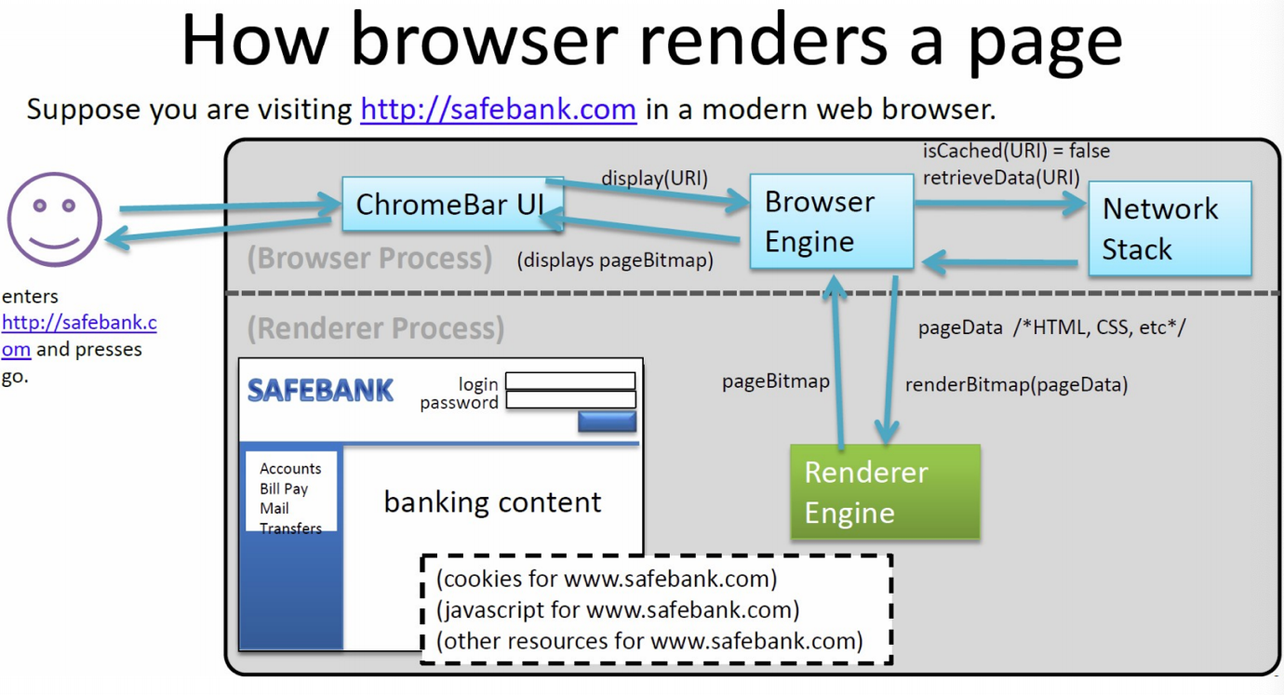Don’t rely on security by ovscurity
* Isolation
* Running remote code is risky
  + Integrity
    - Compromise your machine
    - Install malware rootkit
    - Transcart on your accounts
  + Confidentiality
    - Read info
    - Steal passwords
    - Read your email
* Current Practice

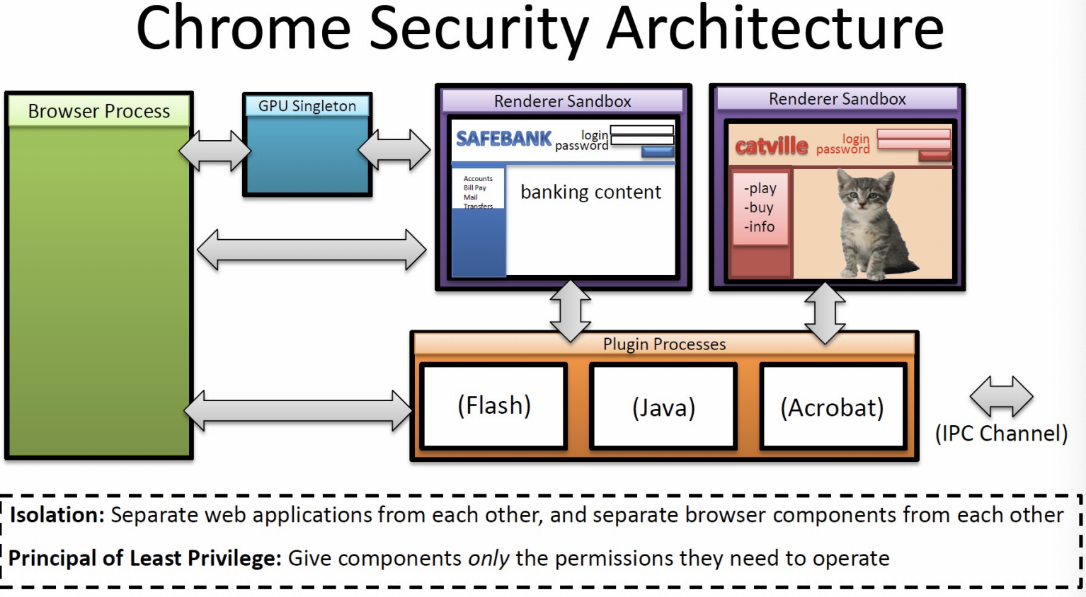

* Frame and iFrame
  + Window may contain frames from different sources
    - Frame: rigid division as part of frameset
    - iFrame: floating inline frame
  + iFrame example
* iFrame example:

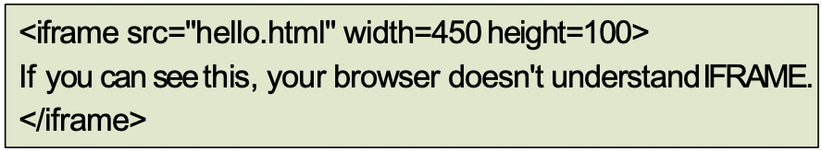

* Why use frames?
  + Delegate screen area to content from another source
  + Browser provides isolation based on frames
* Browser sandbox
  + Goal
    - Run remote web apps safely
    - Limited access to OS, network and browser data
  + Approach
    - Isolate sites in different security contexts
    - Browser manages resources, like an OS
* Comparison with OS

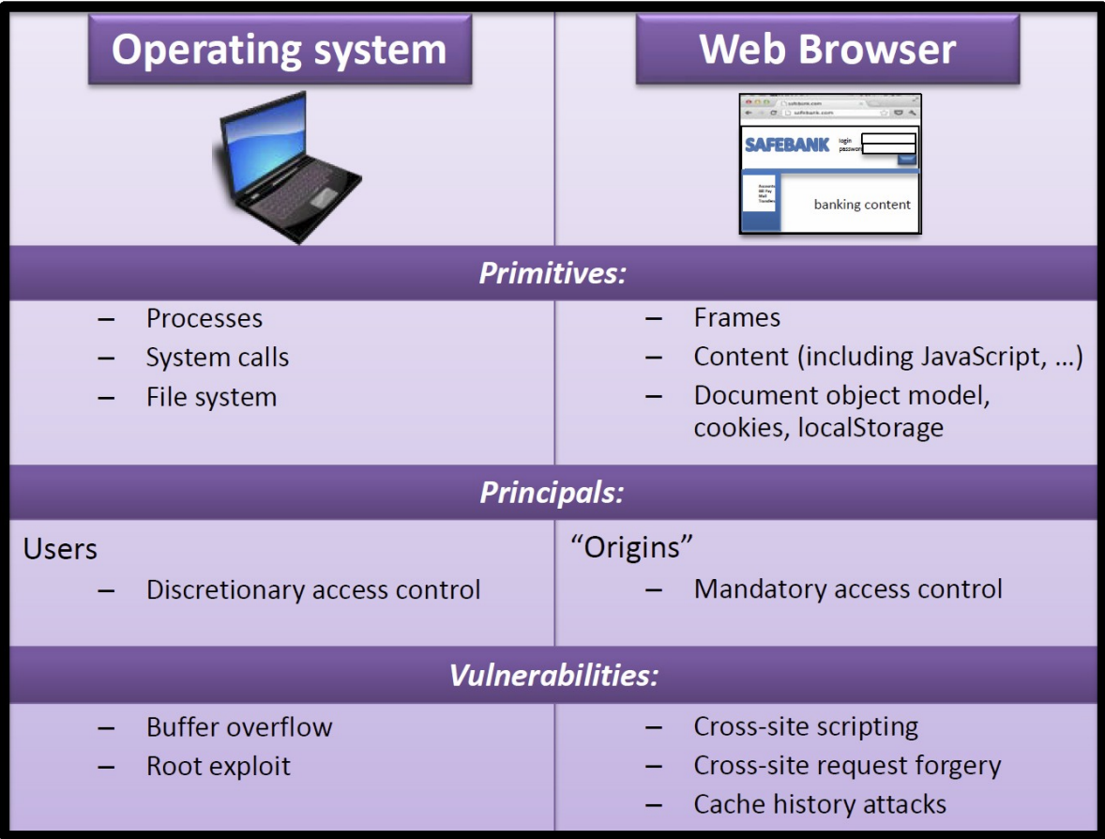

* Client side: Browser Security Policy
  + Browser security goals
    - User can safely visit any web site
  + User can safely visit multiple web sites in same browser
    - Open page from site x cannot interfere with open page from y
* Cookies: Client State
  + 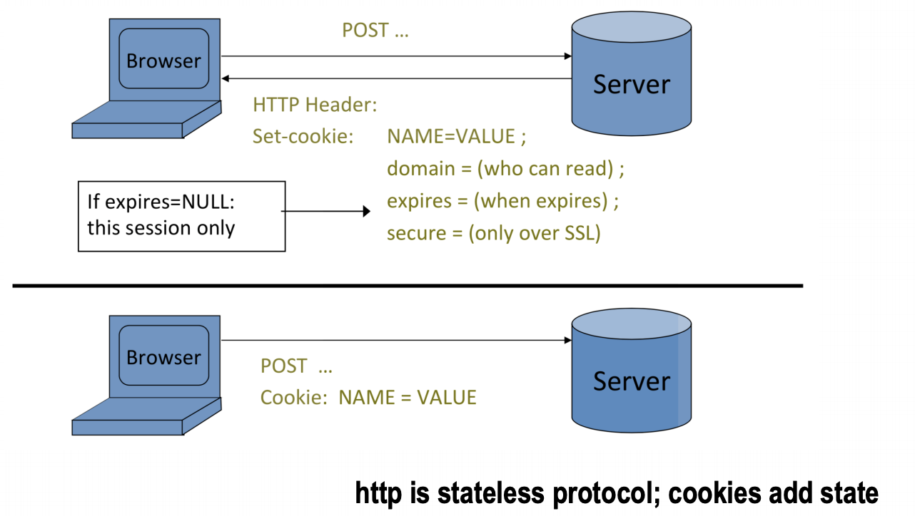Used to store state on user’s machine
* Cookie Authentication

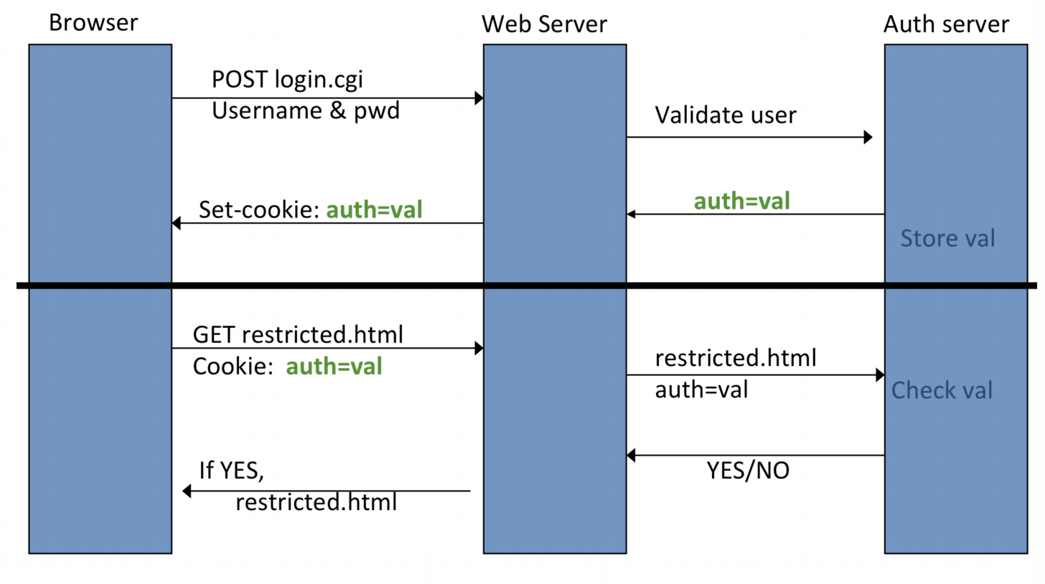

* Cookie security policy
  + Uses:
    - User authentication
    - Personalization
    - User tracking
  + Browser will store
    - At most 20 cookies/site
  + Origin is the tuple <domain, path>
    - Can set cookies valid across a domain suffix
* Secure cookies

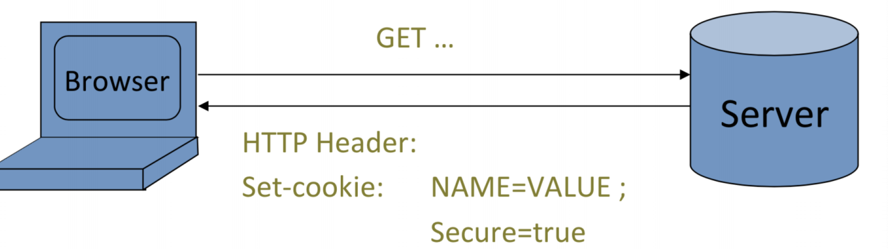

* + Provides confidentiality against network attack
  + No integrity
    - Can rewrite secure cookies over HTTP
      * Network attack can rewrite secure cookies
      * Can log user into attackers account
* Common Threats (Our Focus)
  + Attacks on Server side:
    - Attack setting: Attacker interacts as web app. Client with server web app
    - Goal: Inject attackers code to modify web app
    - SQL code inkection
  + Attack on client side
    - Attack setting:
      * Malicious web app. Client attacking another web app
      * Malicious web server attacking a web app
    - Goal: Inject attacker script into target client browser to attack clients interaction with web app
    - XSS
* Typical web app stack
  + Browser
  + HTTP over TCP/IP
  + Server
    - OS
    - Web server
    - Scripting language
    - Database layer
* Attacking data stores
  + Malicious user knows we will be building an SQL query.
    - They can attempt to confuse the database server by putting in special characters
* SQL Injection Vulnerabilities
  + SQL injection
    - Lack of user input validation vulnerability
    - Allows attacker to directly inkect SQL code into SQL database server
    - Often gives attacker complete control
  + Attack example 1:
    - Name: john’—
    - Password: guess
  + Why does this work?
    - Login verification checked by server by passing a command str to an SQL database interpreter
    - Command string consists of a concatantion of SQL language commands and user input
    - Attackers password input string contains both data and command
    - Attackers command string passed to SQL interpreter and executed
    - SELECT \* FROM members WHERE username = john’==’ AND password = ‘guess’. This is going to log you as john, because rest of the SQL query will be ignored
  + Vulnerable due to invalid assumption by developer
  + 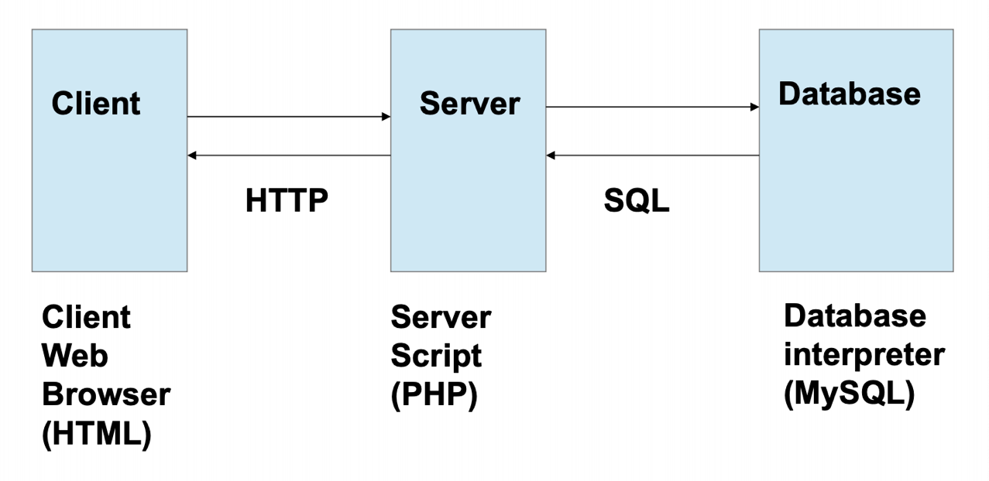Under the Hood: Client server database setup

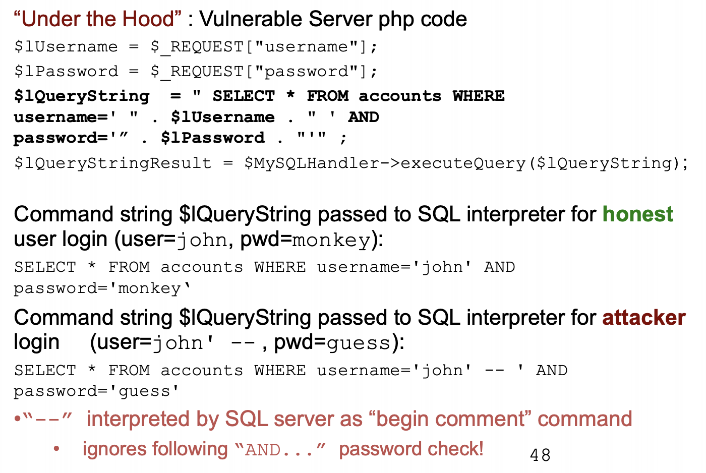

* + Control of SQL commands in the hands of attacker can lead to even more devasting attacks
  + Clever attack example 2:

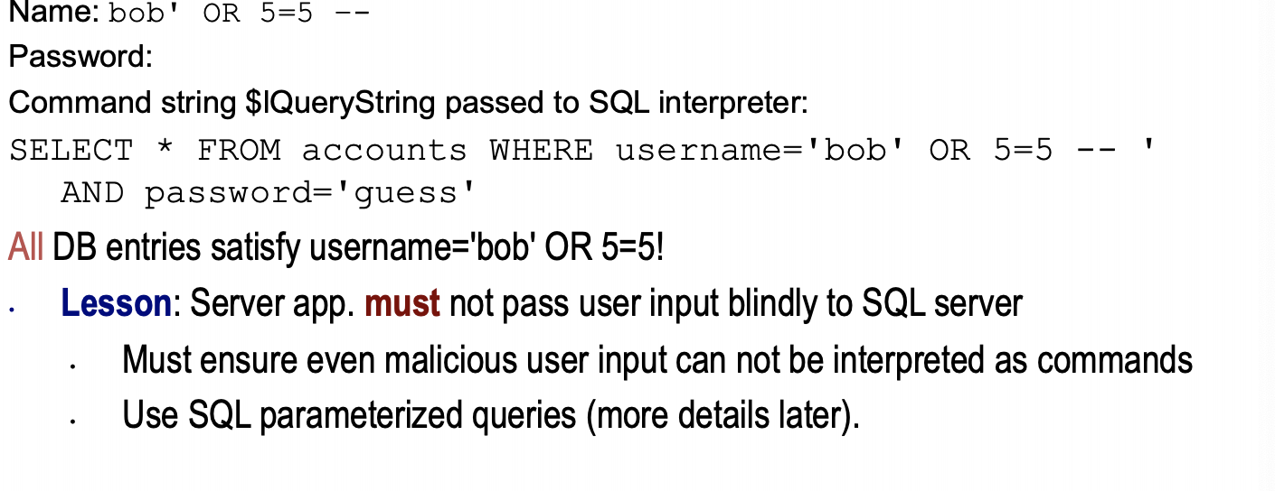

* + SQL in real word
    - #1 in 2013 – 2017 on OWASP
  + Lots of variants of SQLi exploits
    - Can often be used to bypass simple SQLi countermeasures, such as character escaping filters
  + Bypassing simple SQLi filter countermeasures
    - In previous attacks, attacker needed to add ‘ character to terminate the data string and start entering commands
    - What if the ‘ character is escaped by the app
      * Application can replace any occurrence of ‘ by ‘’
        + SQL interpets ‘’ in a data string as the data character ‘ rathter than the string termination symbol
  + Bypass example:
    - The app may also accept numeric user input data
    - numeric data can be passed directly to database without ‘ quotes
    - e.g.

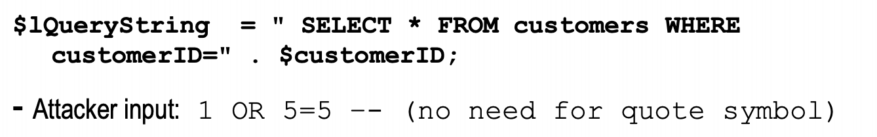

* + Second order SQLi
    - ‘ character in user input string was escaped (replaced by”) by web app
    - A second order vulnerability for string inputs may still be exploitable:
      * Consider app. registering users in database and then retrieving
      * Attack first phase: attacker registers escaped input into database

Lecture 10

* Access control
  + Assumptions
    - System knows who the user is
      * Authentication via name and password, other credential
    - Access requests pass through gatekeeper
      * System must not allow monitor to be bypassed

Resource

User process

Reference

monitor

access request

policy

?

Relationship Among Access Control and Other Security Functions

* Functions related to Access Control
  + Authentication: Verification that the credentials of a user or other system entity are valid
  + Authorization: The granting of a right or permission to a system entity to access a system resource
    - This function determines who is trusted for a given purpose
  + Audit: An independent review and examination of system records and activities
    - In order to test for adequacy of system controls, to ensure compliance with established policy and operational procedures, to detect breaches in security and to recommend any indicated changes in control, policy and procedures
* Access Control Matrix
  + Scenario: an entity may enable another entity to access some resource
  + Often provided using an access matrix
    - One dimension consists of identified subjects that may attempt data access to the resources
    - the other dimension lists the objects that may be accessed
  + Each entry in the matrix indicates the access rights of a particular subject for a particular object.

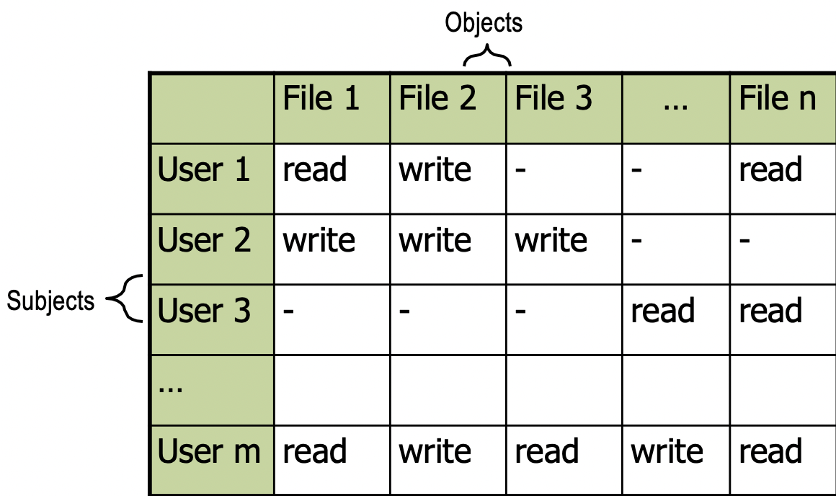

* Two implementation concepts
  + ACL
    - Store column of matrix with the resource
  + Capability
    - User holds a ticket for each resource
    - Two variations
      * Store row of matrix with user, under OS control
      * Unforgeable ticket in user space
    - ACL are widely used, often with groups
    - 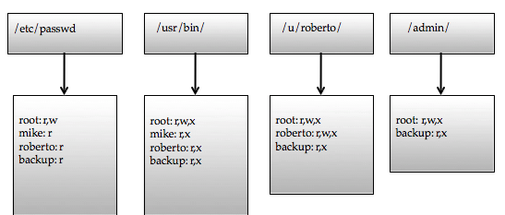Some aspects of capability concept are used in many systems

* Capability Examples
  + Takes a subject centered approach to access control. It defines for each subject s, the list of objects for which s has nonempty access control rights.

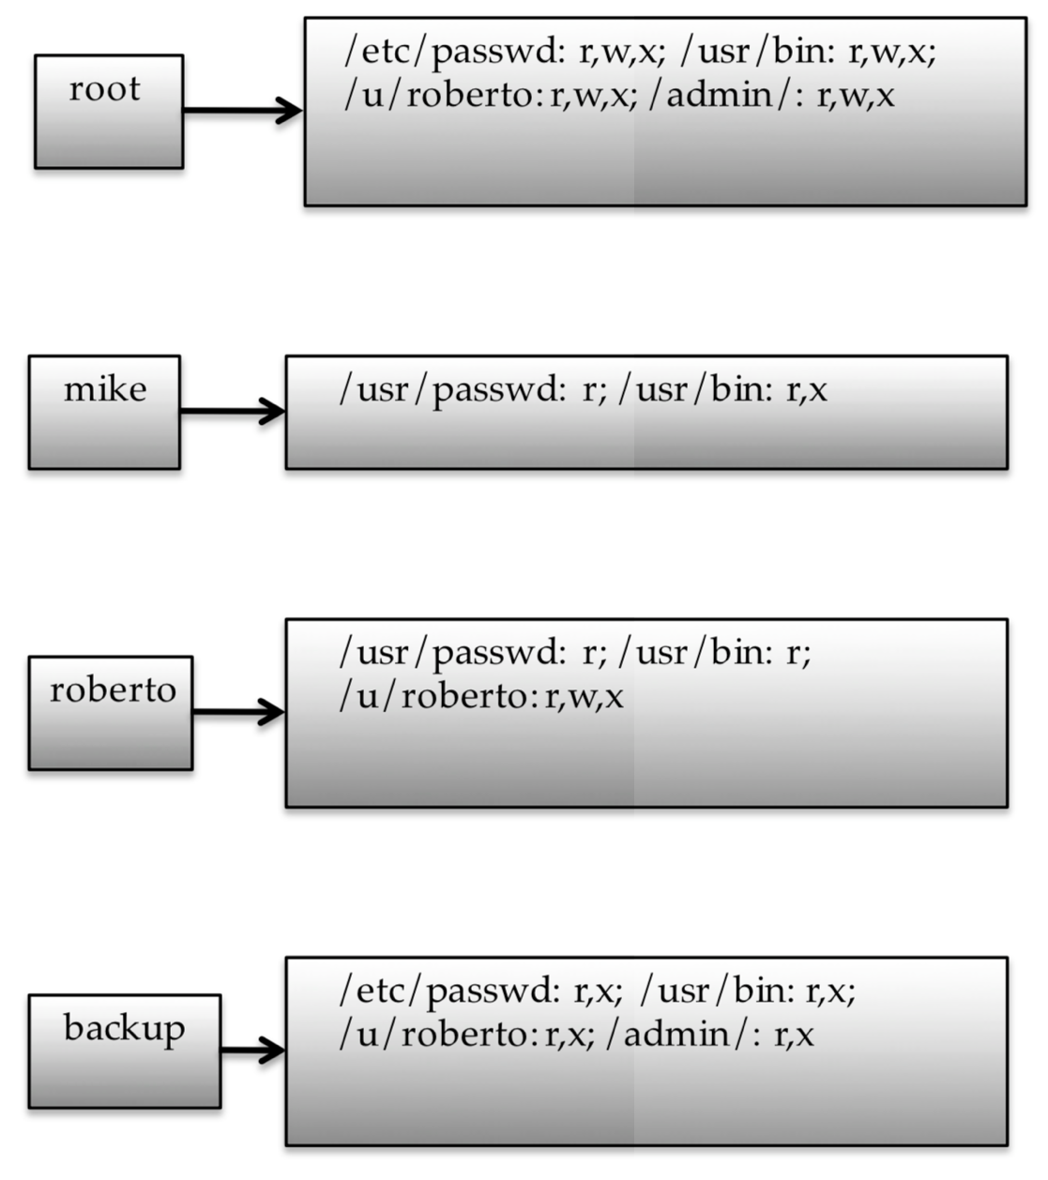

* ACL vs Capabilities
  + ACL
    - Associate list with each object
    - Check user/group against list
    - Relies on authentication: need to know user
  + Capabilites
    - Capability is unforgeable ticket
      * Random bit sequence, or managed by OS
      * Can be passed from one process to another
    - Reference monitor check ticket
      * Does not need to know identity of user/process
* Role based Access Control
  + Role = set of users
    - Admin, PowerUser, User, Guest
    - Assign permissions to roles; each user gets permission
  + Role hierarchy
    - Partial order of roles
    - Each role gets permissions of roles below
    - List only new permissions given to each role

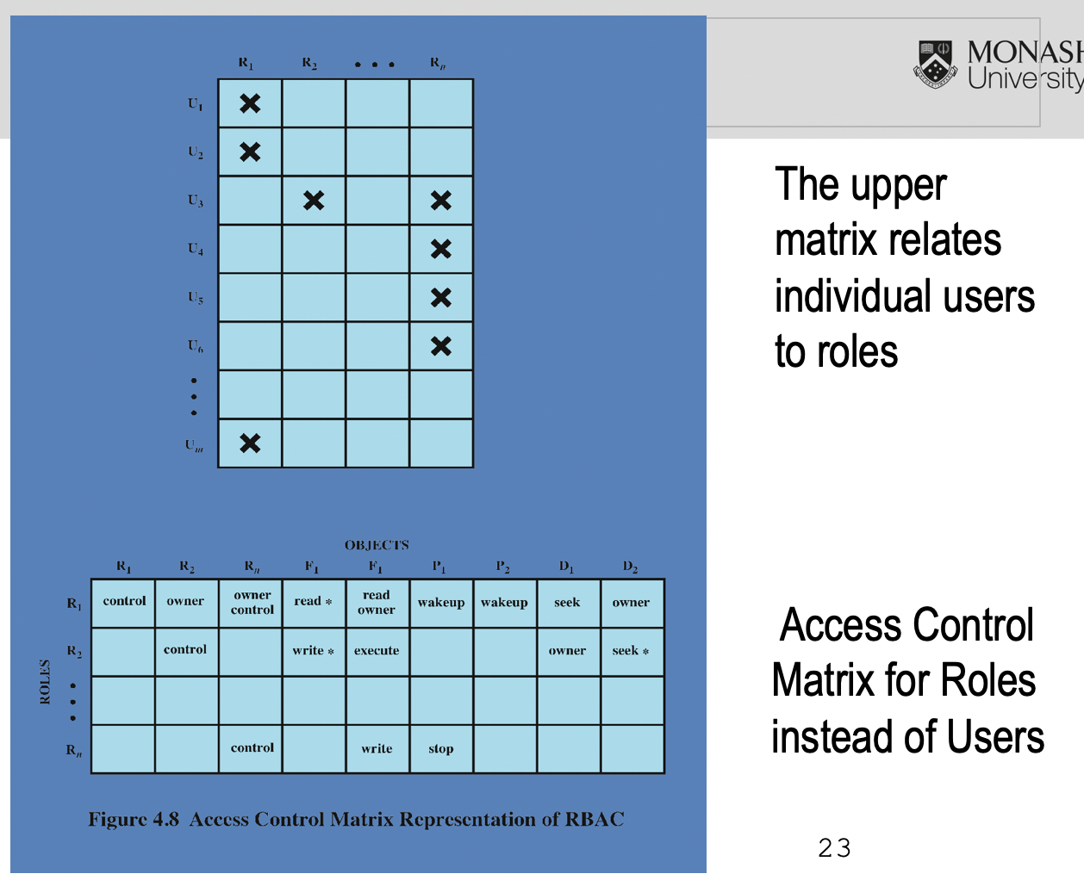

Individuals

Roles

Resources

engineering

marketing

Server 1

Server 3

Server 2

human res

Advantage: users change more frequently than roles

* Efficiency of RBAC
  + RBAC has the potential to offer greater admin efficiency for:
    - Giving permissions to new users
    - Reviewing and removing old priviliges
    - Changes in a users job assignment
    - Removal of privileges for leaving employees
  + There is usually a direct relationship between the cost of admin and the number of associations that must be managed
  + The larger the number of associations, the costlier and more error-prone access control admin
  + In most organisations, RBAC reduces the number of associations that must be manahed
* UNIX File Access Control
  + UNIX files are administrated using inodes
    - Control structures with key info needed for a particular file
    - Serveral files names may be associated with a single inode
    - An active inode is associated with exactly one file
    - file attributes, permissions and control info are sorted in the inode
    - on the disk there is an inode table that contains the inodes of all the files in the file system
    - When a file is opened its inode is brought into main memory and stored in a memory resident inode tabke
  + Directories are structed in a hierarchical tree
    - May contain files and or other directories
    - contains file names plus pointers to associated inodes

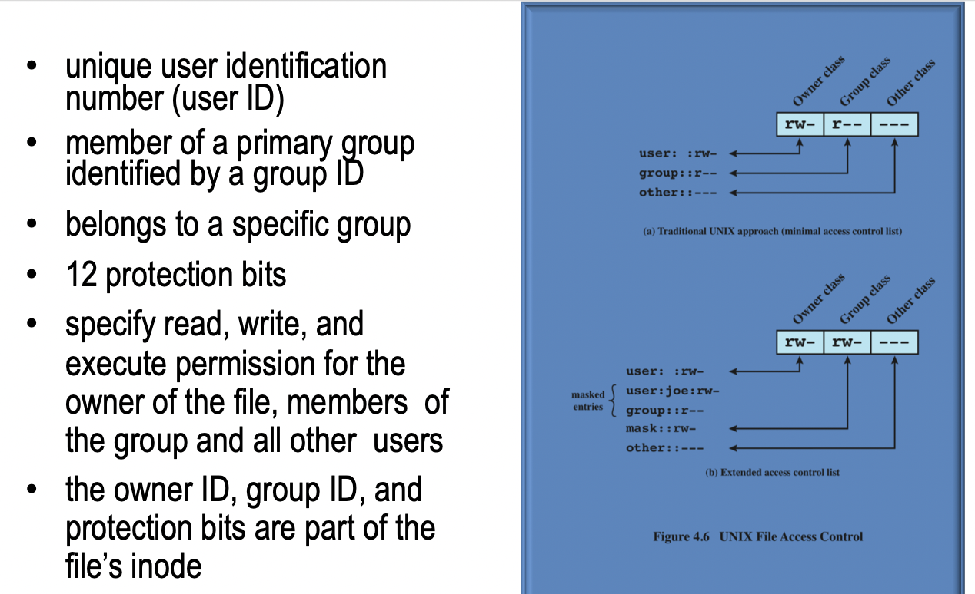

* + Each file has owner and group
  + Permissions set by owner
    - Read, write, execute

- rwx rwx rwx

ownr grp othr

setid

* + - Owener, group, other
    - Represented by vector of four octal values
  + Only owner, root can change permissions
    - This privilege cannot be delegated or share
  + 3 setid bits